Message from the President

In 2018 the value of cryptocurrencies tumbled 81% from $573 Billion to just over $100 Billion. ICO funding has also dried up. In January and February ICOs were pulling in about $2.5 Billion per month. In November, ICO funding has nearly vanished except for about $65 Million. The number of “real” blockchain projects success stories are just trickling in. However, despite all of the clouds on the horizon, there is a silver lining.

Governments around the world are in a race to become the cryptocurrency and blockchain centers of the universe. In the US, places like Wyoming, Ohio, Puerto Rico, Arizona and many others are seriously considering and passing blockchain friendly legislation. The State of Ohio is about to start collecting taxes in cryptocurrency. West Virginia is promoting blockchain voting, and the Health and Human Services just had their blockchain solution pass the Authority to Operate (this is a big deal). Gangwon-do Province of South Korea is about to launch their own token. All around the world, government leaders are cautiously exploring blockchain technology.

There is no doubt that 2018 has been a shake-out year. But we needed it. Thankfully, the Gartner Hype Cycle provides some context for us to look back and forward. As we look back at 2018, I see that those who are still standing are wiser, a little battle hardened, and better equipped to move into the future. Leading transformative change is not for wimps. It will require sober thinking, grit determination, and courage. John Wayne had it right when he said that “Courage is being scared to death but saddling up anyway”. He also said, “Hurry it up. We’re burning daylight”. So, as you read this newsletter, join the men and women of the GBA as we ride into this new year with true grit, determination and a passion for impacting the future.

GBA Headlines & Interviews
- Chris Snook, host of the Token Standard webinar presents Global Government Leaders and Blockchain with Gerard Dache on Wednesday, January 2 (Registration Required)
- Coin Rivet Interview of GBA Founder, Gerard Dache
- Forbes: Tokenized Trade Associations? Government Blockchain Group Eyes Token Ecosystem
- Government Blockchain Association Plans to Start a GBA Token for Community Members
- Growth Hacking interview by Muhammad Siddique of GBA Founder, Gerard Dache
- International Government Blockchain Association Keen to Launch GBA Token

New GBA Resources

New Training Courses (added to the training catalog)
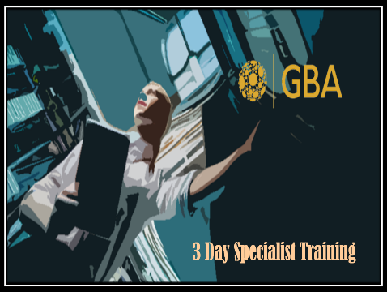
  - Cryptocurrency Investigator Course (Online) – This course is designed for law enforcement and compliance professionals to help them identify and investigate illicit activities involving cryptocurrency.
  - Financial Specialist Course – This course is for financial services professionals to help them understand what the technology is and how it impacts their industry.
  - Healthcare Specialist Course - This course is for healthcare professionals to help them understand what the technology is and how it impacts their industry.
  - Legal & Legislative Course - This course helps legal and legislative professionals understand the technology, its impact on legal and regulatory systems as well as clients and constituents.

Calls to Action
- Nominate a GBA Member for a FED 100 Award – We are fortunate to have some amazing leaders in the GBA. Let the rest of the world know what we already know. Please consider nominating a fellow GBA member for this prestigious award. The more we edify each other, the higher the value or our mutual association. The deadline is January 4th.
- Please complete your profile (especially your location). Many people are searching the Member Directory and are telling me they can’t find people because our members are not completing their profile. If you don’t add your location, your name does not appear in any searches.
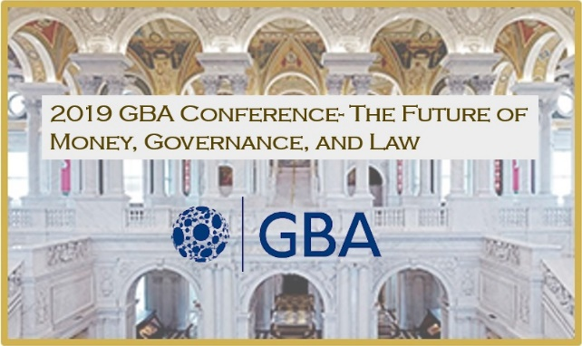
- Help plan the 2019 GBA Conference – The Future of Money, Governance, and Law - We are planning a major event to be held in the US Capitol, Library of Congress or similar venue. The purpose of the event will be to help public and private sector leaders understand and prepare for the impact of blockchain and cryptocurrency on government institutions.
- Help Wanted: GBA Government Advisory Board - If you know a public official that would be willing to volunteer as a GBA Government Advisor, please have that individual contact Gerard Dache.
- Help Wanted: Internships – The GBA is looking for interns to work alongside senior level blockchain professionals in GBA Working Groups. Interested candidates should download and review the GBA Internship Job Description and if interested, contact Peter Mcaliney, the University & Education Community of Interest Leader.
- Help Wanted: Rain Maker – The GBA is about to finish our first calendar year as an organization. And, while we have accomplished a great deal together, we need your help financially. We are looking for people who know how to help organizations like ours raise funds through grants, investing, membership sales, training and, events. If you know anyone with this skill set, please have them contact Gerard Dache.
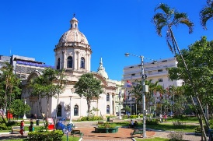
GBA Programs
- GBA Advisory Committees – GBA would like to welcome Dr Lluïsa Marsal Llacuna, the Technological Innovation and International Action Lead of the Catalan Institute of Energy as the newest member of the government advisory committee. The advisory committees will be meeting in January to discuss a range of proposals for 2019 including new pricing, programs and methods.
- Blockchain Certification Program – The GBA certification program is consolidating from five courses to three. The new course will be Blockchain Foundations, Specialist, and Executive Consultant. It will include the same basic content. Also, Working Groups are developing domain specific training certifications. For more information about training, contact Eric Guthrie.
- Government Level Membership – The GBA website now describes a new level of membership for governments that want to work with the GBA in a Public-Private Partnership. This level of membership allows governments to coordinate with global resources on solutions explicitly related to government use-cases. The focus of the government-wide membership is to facilitate the coordination of blockchain activities across a government-wide scope.
- Investor & Start Up Connection – The GBA Investor & Startup Community of Interest includes GBA members who have resources to invest in projects and are looking for blockchain projects to invest in. It also includes GBA members that have projects that need angel or seed capital. Many of the projects are excellent impact investments and we are looking to engage with more venture capital organizations and family offices that want to invest in projects that are using blockchain technologies to address many of the United Nation's Sustainable Development Goals (SDGs). Please see this list of Blockchain Projects Seeking Funding. For more information about any of these projects, contact Bill Elder.
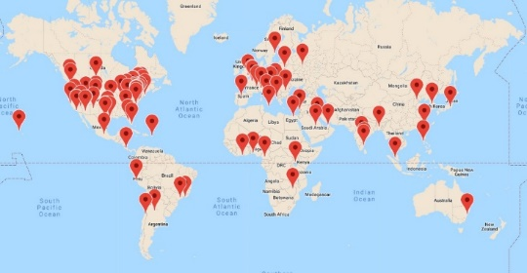
Chapter News
- New GBA Chapters - The GBA has established new chapter in Silicon Valley Chapter, The Nordics, Germany, Andorra, Barcelona (Spain), Republic of Georgia, Cleveland (Ohio, USA), and Lagos (Nigeria)
- Africa Update
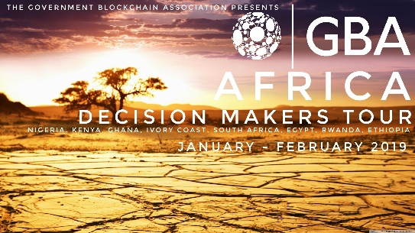
- GBA Africa Decision Makers Tour - Mr. Armand Gaetan Ngueti is preparing to launch the GBA Africa Decision Makers Tour 2019. The tour will include Nigeria, Kenya, Ghana, Ivory Coast, South Africa, Egypt & Ethiopia. Mr. Gaetan will follow a high-level agenda, meeting with local government officials in charge of telecommunications, technology & digital economy. He will also interact with local lawmakers, academic leaders, strategic private sector CEO’s, local blockchain community leaders, and related organizations.
- Welcome to the Genesis Block Africa and Africa Blockchain Alliance as GBA members in Africa and partners in creating the community that will serve as the bedrock of future innovations and accomplishments in the region.
- Africa Fintech will be hosted by Mr. Armand Gaetan Ngueti.
- Iran - GBA welcomes Sepehr Mohamadi to the GBA. Sepehr is an organizer of at least two blockchain groups in Iran with a combined total of nearly 3,000 members. GBA welcomes Sepher and thought leaders like him around the world to utilize our Association and Blockchain Technology for crossing boundaries and solving problems.
- Italy – The first GBA certification course in Europe was conducted in Rome this past October. It was organized by Mirko De Maldè (Rome Chapter Leader) and Nabeel Malik (GBA Training Partner & Mining & Cryptocurrency Working Group Leader)
- Japan
  - The GBA Tokyo Chapter led by Kohei Kurihara has organized the Blockchain and Voting experiment in Tsukuba. They have also begun discussions in the Gov/Tech space with government officials in the Economic Affairs, Internal Communication Affairs and others.
  - Kohei Kurihara also promoted GBA at the Sustainable Development Goals Conference highlighting the positive work that he and his colleagues are doing.
  - The GBA Tokyo Chapter provided valuable content Blockchain in Japan Report from the EU-Japan Centre for Industrial Cooperation.
- England (London)
  - GBA London Chapter Addressing Overpayments of Benefits - The London Chapter is putting together a project team to propose blockchain solutions to the British government.
  - Siddhi Trivedi represented the GBA at the All-Party Parliamentary Group on Artificial Intelligence (APPG AI). The APPG AI is co-chaired by Stephen Metcalfe MP and Lord Clement-Jones CBE and is comprised of Members of Parliament, and government leaders. This informal, cross party group is supported by industry leaders such as Accenture, Barclays, BP, British Standards Institution, CMS Cameron McKenna Nabarro Olswang, Deloitte, EDF Energy, Ernst and Young, KPMG, Microsoft, Oxford University Computer Science, and PwC.
  - Shiv Aggarwal represented the GBA at Healthcare Unblocked 2018. This was UK’s first must-attend conference dedicated to advancing blockchain and Distributed Ledger Technology in healthcare. Healthcare Unblocked 2018 assembled the ‘who’s who’ of expertise and experience in this cutting-edge field.
- Spain
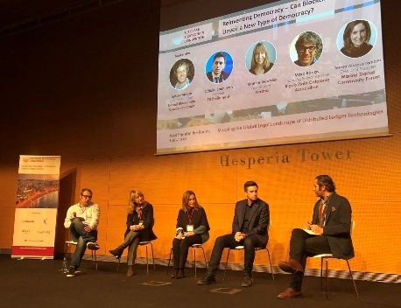
  - Barcelona - Ismael Arribas moderated a panel on the subject of eDemocracy and Blockchain, a new type of democracy. The event was organized by the European Blockchain Convention. Participants included Victoria Gago, Daniel Salmerón, and Catalin Ivan Sorin, a member of the European Parliament and founder of AND a new politician party which introduces blockchain for the voting process between others.
  - Madrid – GBA & Madrid Startups Community Forum are discussing and progressing understanding of Artificial Intelligence and Internet of Things.
  - Valladoid – The Valladoid Chapter has had several meetings (private and public events) including with the International Chamber of Commerce of Valladolid on topics including the Agricultural Consortium with East Africa and Spain.
- Malta
  - The GBA and the OXBC - Oxford Blockchain Foundation co-organized and hosted the Malta Blockchain Summit. Special thanks for these GBA Chapter leaders: Mirko De Maldè (Rome), Oliver Marco La Rosa (Malta), Maria Marenco (Nordics), Nicolae Ghibu (Romania).
  - Malta 2018 Top Blockchain Influencers in the World – Ranked GBA members Dr. Gordon Jones (Healthcare & Voting Working Groups) and Kohei Kurihara (GBA Tokyo Chapter Leader) in the top 11 influential people in blockchain in the world. The GBA is currently the largest blockchain industry association with some of the highest caliber blockchain people and organizations on the planet. Congratulations on the honors, well deserved!
- United States
  - Colorado (Denver)
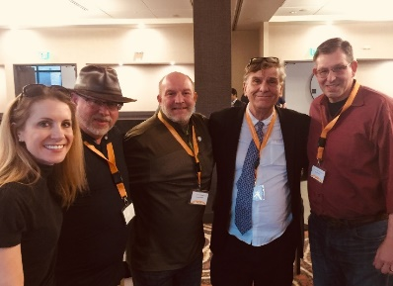
    - In Denver, John Carpenter organized a successful Denver Blockchain Week (October 13-20) which had IBM and Hyperledger workshops and the Global Blockchain summit.
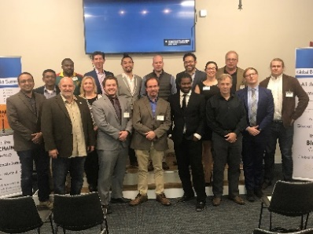
    - John Carpenter also facilitated the GBA Leadership Forum on October 18th, for which we are very thankful. We made some significant decisions about how we are going to operate moving forward.
    - GBA hosted their very first Crypto-Nite in Denver, raising awareness of businesses that use cryptocurrency to the local population. Big shout out to our venue, the one-of-a-kind Improper City, a truck-yard and craft beer/coffee bar. This funky and artistic space had their grand opening the night AFTER we hosted Crypto-Nite. We booked it just in time!

  - California (Long Beach) - Winter Kickoff (Jan 24th)
  - Georgia (Atlanta) – The Atlanta Chapter conducted a Blockchain / Supply Chain Demo. Participants included SAP, Center for Disease Control (CDC), county and state economic development teams, and a GBA certified Blockchain Specialist PhD student (who flew in from Detroit for the event). Special thanks to GBA Corporate Member, Blocnets for their support and blockchain supply chain technology.
  - Hawaii – The GBA Chapter in Hawaii has assembled an impressive community of university professors, and government leaders including civil, military and legislative leaders. GBA Certification training scheduled for 2019.
- Ohio (Cleveland) - GBA was a media partner and had a booth at Blockland.
  - Virginia - The Tysons Chamber of Commerce invited the GBA to participate in their Tysons2050 Community Engagement event. This event focused on AI, Education, Cybersecurity and Blockchain. Eric Ubias, Ajay Chandhok (Cybersecurity Working Group Lead) and Daniel Yim (GBA Reston Chapter Leader) participated in the event.
  - Vermont (Burlington) – The Vermont GBA Chapter is reviewing the GBA Cybersecurity document.
  - Washington (DC) - The GBA participated in the Washington Elite AI Conference in the DC Convention Center.

Working Groups
- Blockchain Application Architecture Working Group (BAAWG) – Thanks to Will Button for starting this group. They will be responsible for studying and recommending best practices for building scalable, efﬁcient blockchain solutions.
- Budget, Accounting & Transparency (BAT) – This Working Group has started a new project that will establish an open source platform allowing local government entities to manage lottery programs using blockchain technology. Once funds are tokenized and stored on a smart contract, blockchain technology can be used for budgeting, appropriations and tracking of public funds.
- Healthcare
  - The Healthcare Working Group is developing a Global Blockchain Healthcare Certification Standard. The standards will be used to develop training that will integrate with the GBA training program and certified training developed by other GBA Working Groups.
  - The Healthcare Working Group is also working with GBA member company, Dhonor to use blockchain technology to improve the matching of organ and blood donations with waiting patients. GBA is committed to making a positive impact on the lives of citizens around the world. Thanks to Maria Marenco, Mirko De Maldè and Brennan Bennett for leading this group.
- Land Titling
  - John Dean Markunas delivered the keynote address at TUFE 2018 on “The Transformation of Global Land Registry Systems: Protecting Rights and Advancing Economic Development with Blockchain". The 3-day conference was an international, interdisciplinary conference in Athens, Greece organized with the collaboration of four European and International Organizations.
  - The Foundation for International Blockchain & Real Estate (FIBREE) and the GBA have formed a synergistic partnership to collaborate on blockchain use in the real estate industry. With GBA’s 90+ global chapters and FIBREE’s international expansion, we are now part of a global community that is changing the world, block-by-block.
- Legislative & Policy – This Working Group submitted Comments on H. R. 6913, The “Blockchain Promotion Act to the US Congress and is working on a GBA Blockchain Legal Specialist Certification Course Standards. The Working Group is also developing a GBA Certified Legal Specialist Certification Course standards.
- Mining & Cryptocurrency – The GBA Token Whitepaper is on schedule to be baselined before the end of 2018 and we will begin looking for technology partners to implement it. The current concept for the token can be viewed on the GBA Token Overview Page.
- Telcom, Internet & Communications (New) – Thanks to Srinivas Konteti for volunteering to lead this group.

Events

Check out the GBA calendar to view Upcoming Conferences including:
- January
  - Blockchainge DC 2019 (Washington, DC)
- March
  - Shared Services and Outsourcing Week (Disney’s Coronado Spring Resort – Orlando) – Gerard Dache, GBA President will be speaking at this event.

New GBA Corporate Members

Organization | Description
Blockchain Ecosystem Advisors  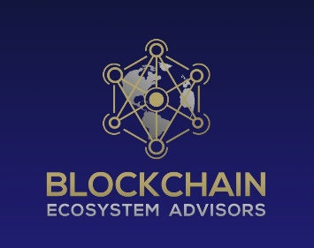 | Blockchain Ecosystems Advisors is helping to grow, cultivate, and scale your neighborhood blockchain ecosystem into city, state, and global size!! We have experts in everything blockchain. We can help you fill in the gaps and launch from blockchain architecture, blockchain security compliance, blockchain startups, ICOs, legal, accounting, taxes, executive education, and enterprise crypto mining farms to AgTech, BioTech, Big Data, Machine Learning, IoT, and AI. We are here to serve new and existing businesses by helping them understand blockchain technologies and develop a strategy to market utilization and growth, first locally then beyond!! Think of it like starting a garden in your own backyard, then community size, then co-op farmer size. Blockchains have many moving parts. Let us help you grow!!
Blockchain Intelligence Group  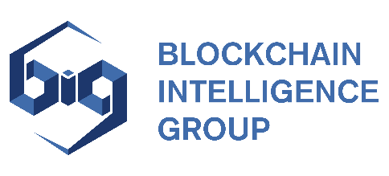 | The Blockchain Intelligence Group, (BIG) is bringing cryptocurrency mainstream by giving our clients and users peace of mind. Our proprietary and Blockchain-agnostic search and analytics solutions bring security and accountability to cryptocurrency.
Blockchain Nigeria User Group  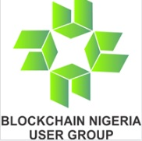 | The Blockchain Nigeria User Group (BNUG) has been the voice of Blockchain and Cryptocurrency Technology in Nigeria since 2016. We speak for an industry that aims to touch the daily lives of Nigerians in every corner of the country — by providing business, jobs, career opportunities, and by investing in the communities we serve. Blockchain Nigeria User Group is a not-for-profit, industry-funded association representing one of the fastest growing industries on the planet. BNUG is a strong advocate for Blockchain Technology in Nigeria and works with all levels of government and other stakeholders to support employment growth and career opportunities in Blockchain Technology, to promote and sustain community development initiatives from coast-to-coast, and to enhance consumer safety and industry competitiveness. BNUG also provides its members with a full range of services and programs including education and training, benchmarking and best practices, networking, advocacy, and industry information.
Blockchain Playbook  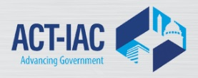 | Blockchain Playbook for the U.S. Federal Government was developed by the Blockchain Working Group, ACT-IAC Emerging Technology Community of Interest. This Playbook proposes a process and five phases to support the United States Federal Government in its understanding and application of blockchain and distributed ledger technologies for its mission. Each phase contains a set of key activities organized in functional areas that go beyond just the technical aspects of blockchain but include management, people, process, and acquisition areas.
BNV | BNV is an Association of stock exchanges in Central America and the Caribbean. Its objective is to help clients of the Exchange make the best use of the contracted services, providing assistance for their queries or requirements, and remote access to platforms. We provide simple and fast stock information with a direct connection to the trading platform of the markets organized by the National Stock Exchange.
FIBREE  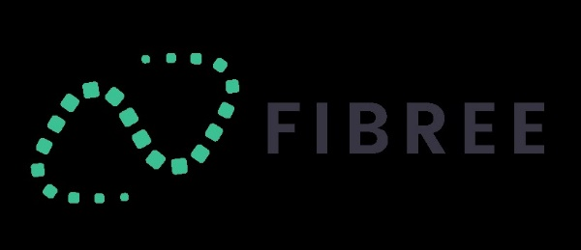 | The Foundation for International Blockchain & Real Estate (FIBREE) is the leading international network for exchanging knowledge between the real estate industry, the IT sector and blockchain technology.
Macurian | Macurian is an A. I. based platform that empowers you to investigate, hypothesis, strategize and take action on customer and prospect insights.
Octo Consulting | Octo Consulting brings together  AGILE ENGINEERING, USER EXPERIENCE, INFRASTRUCTURE AND CLOUD, CYBERSECURITY, DATA VISUALIZATION, and EMERGING TECHNOLOGIES to improve how citizens receive Government services and make a substantial impact on the status quo.
Petronella Technology Group, Inc  . | Petronella Technology Group, Inc. is an internationally trusted IT cybersecurity group that specializes in helping businesses with security and compliance such as NIST, PCI, GDPR & HIPAA. Security risk assessments, remediation, and patented 22-layer systems that cover your People, Process and Technology. Continuity of your business operations starts with cybersafety.
World Tokenomic Forum  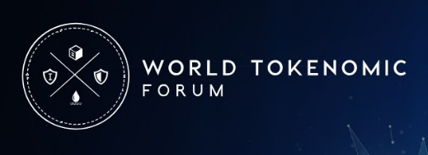 | World Tokenomic Forum is the leading international organization for enabling public-private cooperation, interoperability, and innovation as we move to a new economic order in a token and blockchain based global economy.

