
Government Blockchain Association
Global Gaming Working Group

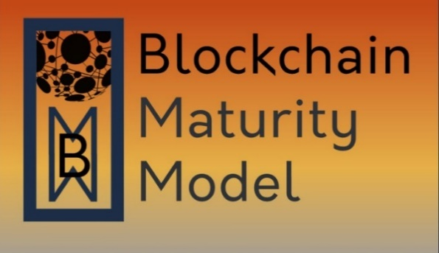
Gaming Supplement

Date: | September 7, 2023
Version: | 0.1

Approvals

 |  | Director, Standards
Meiyappan Masilamani |  | Title |  |  | Date

 |  | Gaming Working Group Lead
Jonathan Baha’1 |  | Title |  |  | Date

© 2023 Government Blockchain Association (GBA)

Contents
1 Introduction 1
1.1 Purpose 1
1.2 Scope 1
1.3 Use 1
1.4 Use Case / Requirements Matrix 1
1.5 Assessment Ratings Considerations 1
2 Game Features 2
2.1 Compliance Reporting 2
2.2 In-Game Tokens 2
2.3 Multi-Player Interactions 2
2.4 Player Registration 2
2.5 Player Data Storage 2
3 Gaming Solution Requirements: 2
3.1 Requirement 1 2
3.2 Requirement 2 2
3.3 Requirement 3 2
Appendix A: TBD 1
Appendix X: List of References A

Introduction

Purpose
This document acts as the guide for the Blockchain Maturity Model (BMM) supplemental review for gaming solutions.

Scope
This supplement applies to solutions that use blockchain to verify the integrity of games of chance, and skills-based games.

Use
When performing a BMM assessment of a gaming solution, the lead assessor will review the supplemental requirements in this document with the Solution Point of Contact (SPoC) to determine which requirements are applicable as “Domain” requirements. Achievement of Domain requirements allows for the additional designation of “Gaming” to the BMM rating.
The Lead Assessor and the SPoC reviews the table below and identifies the Gaming Features row(s) that are applicable to the solution being assessed. Then the requirements that are marked “R” (Required) or “O” (Optional) are reviewed to determine applicability of the requirements to the solution. The result of the analysis is recorded in the assessment plan. The Lead Assessor and the SPoC both sign the assessment plan to reflect their agreement on the BMM supplemental requirements.

Use Case / Requirements Matrix
The matrix below outlines for each Gaming Feature, the requirements that are required (R), optional (O) or not applicable (N/A). Any change to the likely status of the requirement can be agreed between the lead assessor and the solution provider.

Assessment Ratings Considerations
For each agreed requirement, the solution will be deemed to meet or not meet the requirement. A justification for the assessment will be evidenced and recommendations for improvement will be provided. It is important to note that the solution as deemed to meet or not meet the supplemental requirements will be at no greater than the BMM assessment ranking. E.g. if the maturity ranking or relevant capability ranking is a “2”, then the supplemental requirements are assessed as applicable to level “2”. If the solution advances in its capabilities to a higher BMM ranking then, the supplemental requirements will need to be reassessed in accordance with the higher ranking.

Game Features
The Banking and Finance blockchain or DLT solution should be attributed to one or more of the use cases defined below:

Compliance Reporting
Describe this game feature.

In-Game Tokens
Describe this game feature.

Multi-Player Interactions
Describe this game feature.

Player Registration
Describe this game feature.

Player Data Storage
Describe this game feature.

Gaming Solution Requirements:
The specific requirements, some, or all of which may apply to blockchain solutions implemented in the gaming solutions, are as follows:

Requirement 1
The solution shall [Fill in the blank).
Example: Use boxes like this for examples and other informative information to add context to the requirement

Note: These boxes can also be used to provide references or any additional information.

Requirement 2
The solution shall [Fill in the blank).

Requirement 3
The solution shall [Fill in the blank).

Appendix A: TBD
Use the Appendix for additional information that may be needed to be document.

Appendix X: List of References

See BMM Overview Glossary
https://gbaglobal.org/blockchain-maturity-model

