Cybersecurity and Integrity Requirements for Blockchain-Based Voting Solutions
Contents
Exec Summary 2
1. Risk Management Approach 2
2. Security and Integrity Assurance Domains 4
Addendum A: Risk-Management Lens for Assurance Domains 14
Addendum B: Operating Policy Attributes Example 14
Addendum C: Practical Checks for Solution-Record Integrity 15
Versioning
# | Changes | Author | Date
01 | Initial release | AR | 06.24
03 | Structure, ES, Section 1 | AR | 06.28
05 | Section 2, subsections 2.1 – 2.4 | AR | 07.05
08 | Subsections 2.5 – 2.6 | AR | 07.06
09 | Chart, Addendums | AR | 07.08
11 | Cleanup | AR | 07.10

Exec Summary
This supplement supports maturity assessment of a blockchain-enabled voting solution. It identifies cybersecurity, resilience, and evidence expectations used to evaluate the claimed maturity level.
This supplement does not replace formal architecture review, jurisdiction-specific certification, or a full fitness-for-purpose assessment against the voting authority’s existing or planned operational environment.
The focus is election integrity across the end-to-end process. Blockchain-based mechanisms may support tamper-evident records, cryptographic verification and auditability, but they do not replace governance, operational controls, or evidence of effective implementation.
Assessment Boundary: This supplement evaluates maturity, not overall election fitness.
How to Use This Document
This supplement is organized by assurance domains. You can read it from start to finish or jump to the section most relevant to your review. Each domain follows the same pattern: purpose, key assumptions, required evidence, and guidance for assessors. Use the risk-management approach in Section 1 as the common lens.
The main body states the assessment expectations. The addenda provide supporting guidance, examples, and practical reviewer aids. They should be used to interpret and apply the main expectations, not as separate standalone checklists.

1. Risk Management Approach

Risk management starts with the election objectives the solution is meant to support:
- eligible voters must be able to cast ballots,
- votes must remain secret,
- votes must be accurately recorded and counted,
- results must be verifiable,
- evidence must remain available for certification, audit, recount, and post-election challenge.

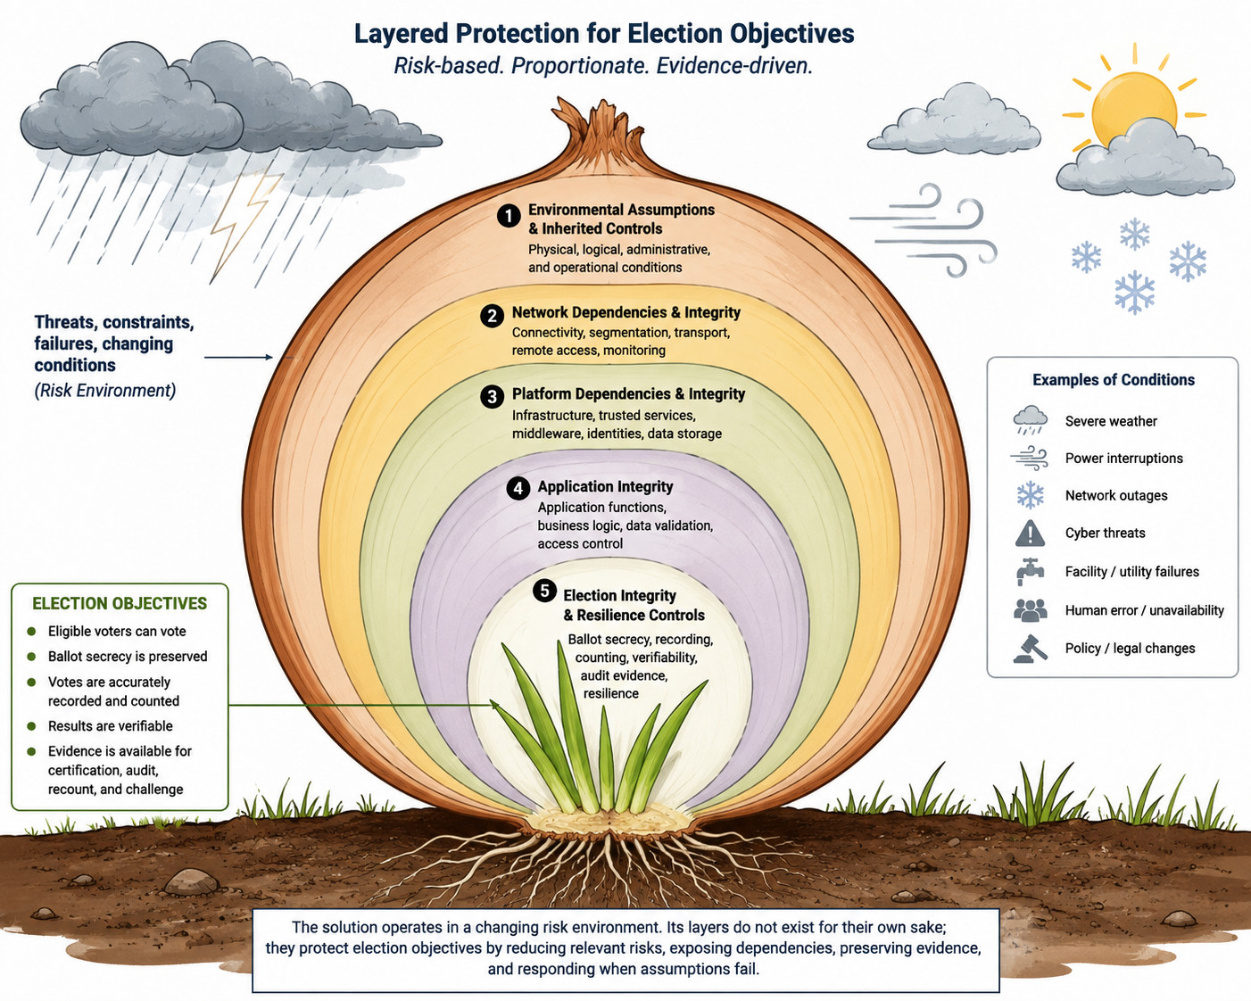
Every voting environment is different. Laws, operating models, threats, election importance and corresponding risk tolerance, available resources, and existing controls will vary by jurisdiction. This supplement does not decide whether a solution is suitable for a specific election or voting authority. That decision belongs to the voting authority through architecture review, certification, and fitness-for-purpose assessment.
The provider’s risk-management capability should match the maturity level claimed for the solution.
A higher maturity claim requires deeper risk analysis, clearer understanding of dependencies and uncertainty, stronger evidence of control effectiveness, and increasing evidence that controls operate efficiently as conditions change.
The solution protects election objectives through technical and operational layers, their associated controls, and supporting procedures. These may include
- application layer;
- platform layer;
- network layer;
- inherited environmental controls.

Each layer should have a clear purpose: it should reduce overall risk exposure to the election objectives by treating more relevant risk than it introduces through secondary risks, dependencies, or operational complexity.
At lower maturity levels, risk treatment may rely on simpler analysis of likelihood, impact, and basic control coverage. At higher maturity levels, the provider is expected to consider risk dynamics, uncertainty, dependencies, variance, confidence, control effectiveness and efficiency, and changes in the threat or operating environment.
The solution is expected to rely on and integrate with existing environmental controls where appropriate, rather than duplicate them. For each external control the solution relies on, the provider shall identify the control, the expected operating assumption, the responsible owner or operator, the evidence supporting that assumption, and the risk or operational impact if the assumption is not met.

Maturity Dependency: The maturity level claimed for the solution should be supported by the provider’s demonstrated risk-management capability. Higher maturity claims require commensurate maturity of the provider’s risk management function.

2. Security and Integrity Assurance Domains

As described in the risk-management approach, the solution protects election objectives through technical and operational layers, their associated controls, and supporting procedures. These may include:
- application functions;
- platform services;
- network connectivity;
- inherited environmental controls;
- election-specific integrity and resilience mechanisms.
For maturity assessment, these layers are examined through assurance domains. Each domain looks at the solution’s risk posture from its own perspective, while supporting the same overall objective: protecting election integrity. For each domain, assessors consider the assumptions it depends on, the risks it reduces, the secondary risks it introduces, and the evidence showing that the resulting tradeoff is justified for the claimed maturity level.
The domains below organize the assessment. They should be applied through the risk-management approach
described above and, where useful, the risk-management lens in Addendum A, so that controls, evidence, and residual risks are considered in proportion to the claimed maturity level and the solution’s stated operating assumptions.
This domain-based assessment does not replace formal architecture review, jurisdiction-specific certification, or fitness-for-purpose assessment.
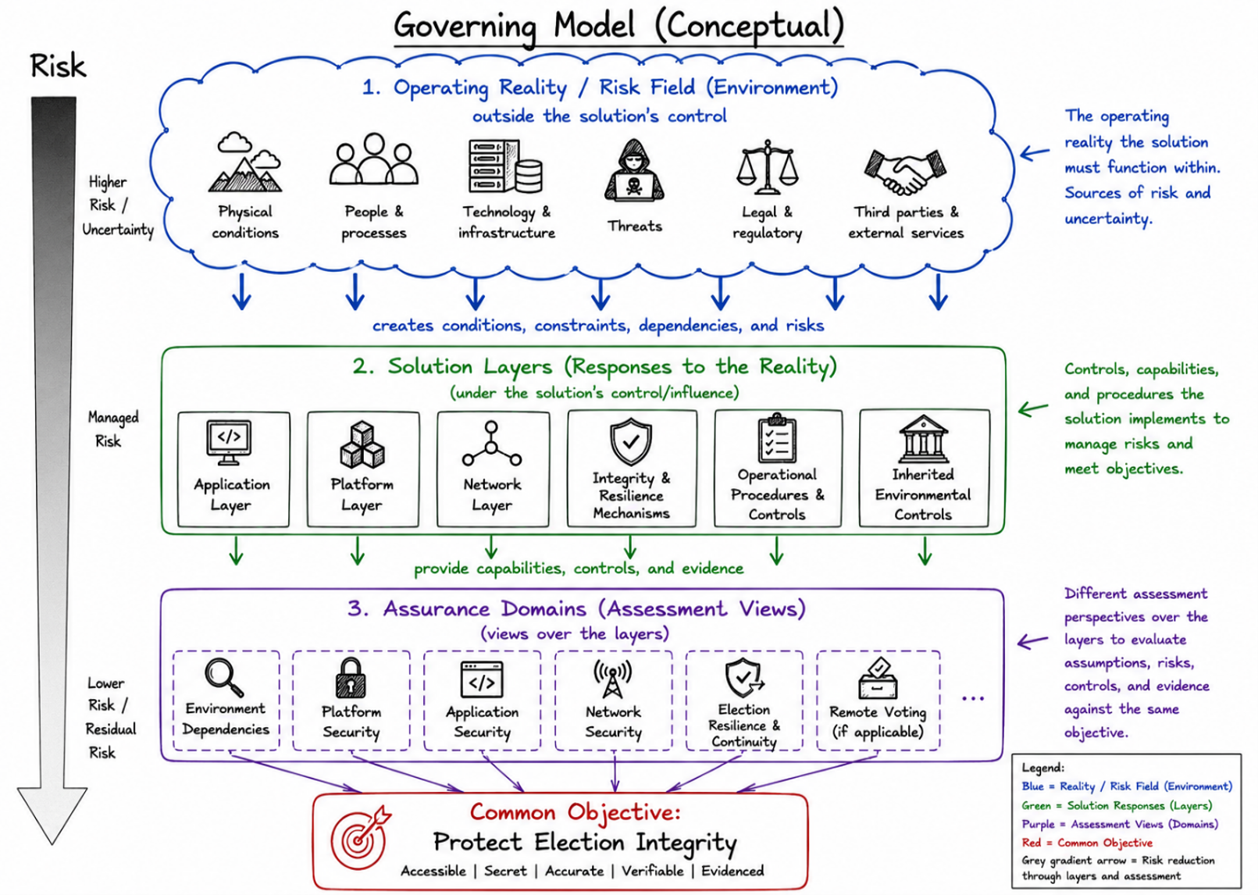

Summary of Assurance Domains
Domain | Main Purpose | Key Focus Areas | Primary Evidence Expected
2.1 Operating Environment Dependencies | Understand dependencies on the broader election environment | Physical security, logical/administrative controls, Zero Trust principles | Documented environmental assumptions, inheritance strategy, verification mechanisms where feasible, and contingency plans
2.2 Platform Dependencies and Integrity | Assess whether platform trust assumptions are justified, bounded, and evidenced | Secure boot, OS integrity, runtime attestation | Platform assumptions, attestation or integrity reports, response procedures for platform failures
2.3 Network Dependencies and Integrity | Assess whether network use is justified, protected, and proportionate | Authorized paths, endpoints, protocols, message flows, segmentation, authentication, availability, and fallback behavior | Documented network use, including required connectivity, authorized communication paths, available visibility or evidence, and fallback or refusal behavior
2.4 Application Integrity | Assess whether required application behavior is demonstrated and policy-consistent | Signed components, immutable artifacts, policy enforcement | Signed release packages, version control records, policy enforcement logs, audit trails
2.5 Election Integrity & Resilience | Support ballot secrecy, verifiability, continuity, and post-election evidence | Ballot secrecy, degraded operation, post-election evidence | Cryptographic proofs, audit trails, safe-failure procedures, post-election evidence packages

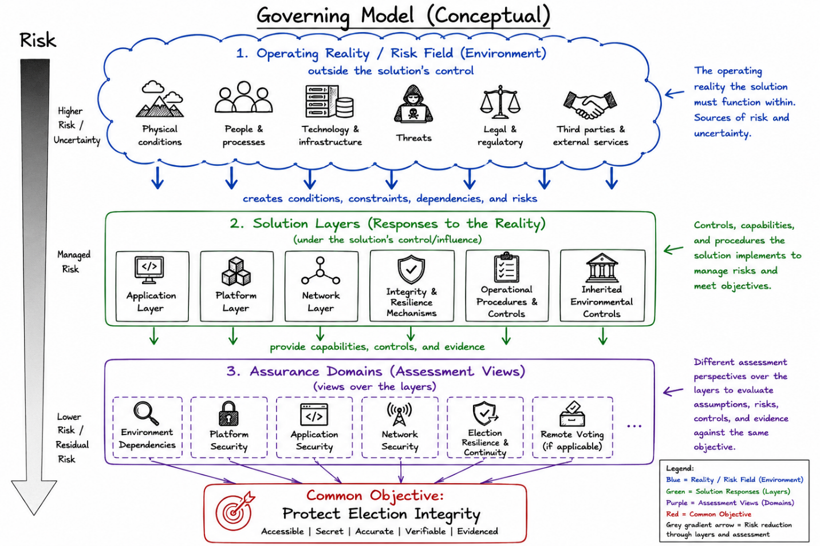
2.1 Operating Environment Dependencies
This domain assesses how the solution identifies, relies on, integrates with, and responds to the physical, logical, administrative, and operational conditions required for secure election operation.
The solution runs inside a larger election environment managed by the voting authority. This environment includes
- physical locations,
- supporting infrastructure,
- administrative processes,
- identity controls,
- personnel controls,
- operational procedures that may affect the secure operation of the solution.
The solution provider does not own or control this environment, but the solution may depend on it.
The provider shall document the environmental assumptions required for secure operation, identify the environmental controls the solution relies on or inherits from, and, where relevant, identify the authority or stakeholder responsible for operating or maintaining those controls.
For maturity assessment, the focus is not whether the provider can duplicate the voting authority’s environmental controls. The focus is whether the provider understands its environmental dependencies, limits reliance on assumptions that cannot be verified, detects observable signs of control degradation where feasible, and defines the expected impact when required assumptions are not met.
Where feasible, environmental assumptions, available control signals, attestations, and evidence sources should be captured in an authorized environment policy or capability profile that the solution can consume. The solution should use this policy or profile to determine which assumptions are observable, verifiable, externally evidenced, or unsupported, and shall apply the corresponding operational policy, restrict functionality, or refuse operation when required assumptions are not met or cannot be verified.

2.1.1 Physical Environment
This subdomain assesses how the solution identifies and relies on physical conditions that may affect secure election operation.
The solution provider is not expected to operate or duplicate physical controls managed by the voting authority or other responsible parties. The provider shall identify the physical conditions the solution depends on, the expected operating assumptions, the evidence supporting those assumptions, and the expected risk or operational impact, if those assumptions are not met.
Physical environment assumptions may include, as applicable:
- secure physical access controls to polling places, server rooms, storage areas, election equipment, and backup media;
- controlled custody, storage, transport, and handling of election components and recovery media;
- reliable power supply, including backup power where required;
- fire detection and suppression capabilities;
- video surveillance or other monitoring where appropriate;
- environmental controls such as temperature, humidity, water protection, and physical tamper protection.
Where feasible, the environment policy or capability profile should identify which physical controls are declared, which are externally evidenced, and which expose telemetry or attestations available to the solution. The solution is not expected to monitor physical controls for which no signal or attestation is provided, but it shall account for those dependencies in its operating assumptions, evidence requirements, and safe-failure behavior.
Guidance for Assessors: The focus is not whether the provider operates the physical environment, but whether the provider understands the physical dependencies of the solution and accounts for them in design, operation, monitoring, and evidence. Where technically observable within the solution boundary, assessors should look for evidence that the solution can detect relevant indicators of interruptions or degradation of services (recurring failures of required operating assumptions).
2.1.2 Logical Environment
This subdomain assesses how the solution identifies and relies on logical and administrative conditions required for secure election operation.

The solution provider is not expected to own or operate the voting authority’s broader logical and administrative environment. However, the solution provider shall document what the solution needs from the logical and administrative environment, what assumptions are being made, how related risks are identified and treated, what residual risks remain, and what evidence supports the claim.

Note: Facility access controls are physical controls by default. Where they are integrated with enterprise IAM, PAM, badge systems, centralized logging, or role-based admission rules, they also create logical and administrative dependencies that shall be documented and assessed under this subdomain.

The solution should address risks related to the logical and administrative environment, including:
- Identity and Access Management (IAM), Privileged Access Management (PAM) (see the Note)
- Personnel vetting / pre-screening procedures
- Time and Attendance controls
- Zero Trust architecture principles — including micro-segmentation (dividing systems into small, isolated zones, so that a breach in one area does not automatically compromise others), explicit verification of every access request and least-privilege access.
- Network segmentation and logical isolation
- Configuration and change management
Note: For externally operated IAM or PAM services, the solution shall define the authorization signals required to permit operations on solution-managed assets. The solution is not expected to determine whether the external identity model is independently trustworthy or appropriate for the voting authority’s broader environment. It shall consume authorized identity and privilege assertions from the environment and enforce them against the solution’s asset inventory, asset classification, permitted-operation model, and current operational policy.
The solution shall restrict or refuse any requested operation when the asset is unknown, the asset classification is missing, the requested operation is not defined, the presented authorization scope does not explicitly permit the operation for that asset category, or current operating conditions prohibit the operation.

Guidance for Assessors: Assessors should evaluate whether the provider understands the logical and administrative dependencies of the solution and accounts for them in design, operation, monitoring, and evidence.
Particular attention should be paid to asset classification, permitted-operation mapping, privileged or emergency operations, service/process identities, policy versioning, revocation or expiration of authorization claims, and audit evidence showing why an operation was allowed, denied, restricted, or escalated.

At higher maturity levels, assessors should also evaluate whether the solution maintains an asset-access expectations model based on design intent, test evidence, and operational data. The model should identify requests that are expected, unusual, or inconsistent for a given solution state and should drive proportionate responses without overriding explicit authorization requirements.

2.2 Platform Dependencies and Integrity
This domain assesses how the solution identifies, relies on, verifies, and responds to platform conditions required for secure election operation. The platform may include hardware, firmware, operating systems, virtualization or container runtimes, local storage, time sources, cryptographic modules, device interfaces, endpoint services, and supporting platform controls.
The solution should treat the underlying platform as not inherently trusted.
The solution provider is not expected to own or operate every platform component used by the voting authority. However, the solution provider shall document what the solution needs from the platform, what assumptions are being made, how related risks are identified and treated, what residual risks remain, and what evidence supports the claim.

Platform assumptions may include, as applicable:
- approved hardware, firmware, operating system, and runtime baselines;
- startup integrity mechanisms (ex.: secure boot);
- operating system integrity and expected configuration state;
- restricted administrative access and privilege enforcement;
- trusted time source or time-synchronization controls where required;
- protected local storage and media handling;
- cryptographic module and key management system (KMS);
- device identity, attestation, or runtime integrity signals;
- controlled attachment of peripherals, scanners, removable media, or other interfaces;
- platform logging, monitoring, and event preservation;
- malware prevention or detection capability.

The platform’s assurance value is its ability to provide a stable execution base, reduce dependence on specific underlying hardware or infrastructure, and absorb defined continuity disruptions without changing authorized application behavior.

At higher maturity levels, evidence should be evaluated against the provider’s stated platform-dependency and continuity model, rather than against a fixed list of preferred evidence types. The key question is whether the platform reduces more dependency and continuity risk than it introduces through complexity, privilege, configuration drift, portability limits, or operational dependency.
Guidance for Assessors: The focus is not whether the provider controls the entire platform, but whether the provider understands the platform dependencies of the solution and accounts for them in design, operation, monitoring, and evidence. Assessors should evaluate whether required platform assumptions are documented, whether verification mechanisms exist where feasible, whether the solution responds appropriately when platform assumptions fail, change, or cannot be evidenced.

2.3 Network Dependencies and Integrity
This domain assesses how the solution uses and protects network dependencies that may affect secure election operation. Network use may support communication between solution components, synchronization, VRL updates, result transmission, audit-data exchange, or other functions defined by the approved operating model.
The provider shall document what network connectivity the solution needs, what assumptions are being made, how related risks are identified and treated, what residual risks remain, and what evidence supports the claim.
Network use should have a clear purpose. The provider shall define which election functions require connectivity, which functions can continue when connectivity is degraded or unavailable, and what restrictions, fallback procedures, or refusal conditions apply when required network assumptions are not met.
Network protections should address, as applicable, authorized communication paths, approved endpoints, permitted protocols, authentication, authorization, data integrity, confidentiality, replay protection, capacity, availability, and retention of network-related evidence.
The solution shall monitor network-relevant events visible to it, such as failed authentication, rejected messages, malformed payloads, replay attempts, unexpected peers, unauthorized message flows, or connectivity failures. Events outside the solution’s visibility shall be identified as observable through authorized telemetry, externally evidenced, or unsupported.
Guidance for Assessors: The focus is not whether the solution avoids networking or uses a preferred network architecture. The focus is whether network use is necessary, limited to defined purposes, protected, evidenced, and proportionate to the claimed maturity level.
2.4 Application Integrity
This supplement does not prescribe or judge a specific application architecture. The provider may implement the voting solution in different ways, provided it can demonstrate that the application layer upholds the required election objectives, approved policies, and security properties at the claimed maturity level.
Any gap between required and demonstrated behavior represents application risk. The provider shall identify the application behavior the solution is expected to enforce, the assumptions that behavior depends on, the evidence showing that the behavior is implemented as intended and the risk or operational impact if required behavior cannot be demonstrated.
Application integrity should address risks such as unauthorized modification, improper execution, policy bypass, configuration drift, unauthorized replacement, and use of unapproved components.
The provider should demonstrate proportionate treatment of these risks by providing evidence that:
- critical application components are digitally signed, versioned, and deployed as immutable artifacts.
- signing certificates remain valid throughout the entire election lifecycle and post-election challenge period.
- the voting authority (or designated body) verifies or cross-signs approved components before deployment.
- application behavior is governed by an approved, versioned policy (human-readable and machine-enforceable) that is digitally signed and controlled during the election process.
- the solution prevents execution of unsigned, outdated, or policy-inconsistent components.
- the solution maintains a verifiable audit trail for component versions, policy changes, deployment approvals, and enforcement decisions.
The application layer may rely on platform, network, and environmental controls. Where application behavior depends on external controls or signals, the provider shall identify the dependency, the expected operating assumption, the evidence supporting that assumption, and the application response when the assumption is not met or cannot be verified.
Guidance for Assessors: The focus is not whether the assessor prefers the application architecture, but whether the provider can demonstrate that the application behaves as required under the claimed maturity level. Particular attention should be paid to signed and immutable artifacts, approved policy enforcement, component provenance, configuration control, authorized replacement, exception handling, and evidence showing why application actions were allowed, denied, restricted, or escalated.
Assessors should evaluate whether the evidence reasonably supports the integrity claim at the assessed maturity level, rather than requiring inspection of the provider’s internal build environment or complete traceability across the supply chain.

2.5 Election Integrity and Resilience Controls

The solution should address election-specific integrity and resilience risks that cut across environment, platform, application, and network layers. These controls focus on preserving ballot secrecy, maintaining safe operation under degraded conditions, and retaining evidence needed to support verification, certification, audit, recount, and post-election challenge activities.

2.5.1 Ballot Secrecy and Voter Privacy

The solution shall preserve ballot secrecy and prevent linkage between voter identity and vote choice through voter authentication, ballot issuance, vote casting, storage, tallying, audit, recount, and post-election verification.
Transparency and auditability mechanisms shall not expose vote choices, voter identities, metadata, timing information, or correlation patterns that could compromise voter privacy.
Note: VRL updates and synchronizations shall be accepted only when explicitly authorized by both the source system and the receiving election system. The solution shall verify source authenticity, destination authorization, update freshness, integrity, and authorization scope before applying the change.

2.5.2 Degraded Operation and Safe Failure

The solution shall define safe operating modes and fallback procedures for degraded conditions, including network unavailability, device failure, power loss, failed attestation, corrupted local records, certificate or signature validation failure, VRL synchronization failure, suspected tampering, failed poll-close transmission, and emergency transition to paper or manual procedures where authorized.

The solution shall restrict functionality, preserve evidence, alert authorized election personnel, and support legally authorized continuity procedures when required assumptions are not met or cannot be verified.

2.5.3 Post-Election Evidence and Dispute Support

The solution shall preserve evidence needed for audits, recounts, certification reviews, and post-election challenges, including cryptographic proofs, signed policies, component versions, configuration baselines, relevant logs, chain-of-custody records, exception records, and verification outputs. Evidence shall be exportable, independently reviewable, protected from alteration, and retained for the legally required period.

Post-election evidence shall support independent review without compromising ballot secrecy or exposing voter-identifying information.

2.6 Mobile / Remote Voting (if permitted by the voting authority)
In the context of voting, personal mobile devices carry a different risk profile. If the voting authority permits mobile or remote voting, the solution must demonstrate diligent evaluation and treatment of that different risk profile. The provider should clearly document the residual risks, so the residual risks are acceptable within its stated risk appetite.
Remote voting may be considered for jurisdiction-authorized use cases such as accessibility, emergency operations, or other special needs.
This supplement does not take a policy position for or against remote voting.
Additional Assurance Considerations for Remote Voting
Personal devices and remote networks should be treated as untrusted, as may be exposed to conditions outside the voting authority’s direct control. Specific protections must be demonstrated to regain some
level of trust.
These protections and additional enabling components shall be included in the assessed scope where they support vote casting, recording, verification, privacy, or auditability.
The solution provider should document the secondary risks associated with introducing those additional protections / components.
The maturity assessment should make those risks and their treatment explicit, so the voting authority can determine whether the residual risks are acceptable under its stated risk appetite and risk tolerances for the intended remote voting use case and election context.

The solution provider should demonstrate proportionate treatment of these risks by:
- treating mobile devices as untrusted endpoints and applying strong Zero Trust controls and clear refusal or restriction rules when required conditions are not met.
- providing end-to-end verifiability appropriate to the election context, including mechanisms for voters and independent auditors to verify recording and tallying integrity without creating transferable proof of vote choice or weakening ballot secrecy.
Note: this is usually discussed as receipt-freeness or coercion resistance: a voter should not be able to prove to a coercer that they voted in a particular way. In other words, the solution may allow a voter to verify that their ballot was handled properly, but it shall not give the voter evidence that can be used to prove their vote choice to someone else.
- using client-side protections, hardware-backed key protection (KMS) where available, and anti-tampering measures as risk-reducing controls. Such mechanisms reduce risk, but do not establish full trust in arbitrary personal devices.
- ensuring that network connectivity for mobile voting is tightly controlled, authenticated, and logged.
- maintaining audit evidence sufficient to support verification, anomaly detection, certification, recount, and post-election review, even when votes originate from personal devices.
Guidance for Assessors: If mobile remote voting is in scope, particular attention should be paid to whether the solution compensates for the absence of physical and logical control over the voter’s device and network environment.
The assessment should not assume that remote voting is acceptable merely because cryptography is used.
The assessment also should not reject remote voting without evaluating.

Addendum A: Risk-Management Lens for Assurance Domains

This lens provides a practical way to apply the risk-management approach consistently across assurance domains. It is not intended to prescribe a rigid method. Assessors may adapt it to the maturity level, solution architecture, election context, and evidence available.

For each assurance domain, assessors should consider:
- what aspect of election integrity the domain supports;
- what assumptions the solution depends on, including environmental, technical, operational, and inherited-control assumptions;
- what risks the domain is intended to reduce;
- what secondary risks, dependencies, or operational complexity are introduced by the related solution layer, control, or procedure;
- what evidence shows that the control works as intended and remains proportionate to the claimed maturity level;
- what response is expected when assumptions are not met, evidence is missing, or conditions change.

The lens should be applied proportionately. At lower maturity levels, evidence may be simpler and more static. At higher maturity levels, assessors should expect
- stronger evidence,
- measurement of control effectiveness and efficiency,
- treatment of uncertainty,
- demonstrated ability to adjust as threats, assumptions, controls, or operating conditions change.

Addendum B: Operating Policy Attributes Example

The following attributes illustrate the type of information that may appear in an approved operating policy, release manifest, or similar machine-enforceable control. They are examples, not a requirement to permanently bind the solution to a single build, version, or dependency set.
Component name / identifier
Component type or role
Approved version
Approved hash / digest
Approved signer
Permitted execution phase
Permitted operating mode
Permitted assets / data categories
Permitted operations
Permitted network/message flows, if any
Required platform/environment assumptions
Expiration, revocation, or replacement rules
Required approvals, including provider and voting authority approval where applicable

Addendum C: Practical Checks for Solution-Record Integrity

This addendum provides practical checks for realistic weaknesses in blockchain-supported voting solutions. It is not a full threat catalog and does not assume that the solution provider is malicious. The focus is on weaknesses that may arise from incomplete supplier control, unclear workflow responsibility, weak artifact validation, incorrect assumptions, or insufficient evidence.

A blockchain mechanism can preserve evidence accepted by the solution. It does not, by itself, prove that the accepted record is correct, complete or authorized. Therefore, assessors should focus on the controls and evidence that exist before, during, and after a record enters the blockchain-supported process.

1. Custom Third-Party Components

Assessors should distinguish generic software dependencies from third-party components specifically designed, adapted, configured, or delivered for the voting solution. Such components are part of the
assessed solution scope.

The provider should demonstrate:
- what each custom third-party component is intended to do;
- what election function it supports;
- who supplied it;
- what behavior is permitted;
- what integration points it uses;
- what evidence shows it was accepted, tested, or otherwise evaluated for its intended role;
- what preventative controls are in place if the component fails or behaves unexpectedly;
- what are the residual risks.
The provider remains accountable for demonstrating that the component fits-for-purpose and role it performs in the voting solution.

2. Undeclared External Communication

Custom third-party components should not create undeclared external communication paths. Any vendor support, update, telemetry, licensing, analytics, diagnostic, or other external communication required by such components should be declared, justified, authorized, restricted, logged, and controlled under the approved operating model.

Where a component is expected to operate without external communication, the provider should demonstrate how such communication is blocked, monitored, or otherwise controlled. Attempted undeclared communication should be logged, restricted or escalated according to policy.

3. Action-to-Control Mapping

The provider should furnish a mapping of material election actions and state transitions to the components that perform or authorize them. For each material action or transition, the provider should identify:

- the expected behavior;
- the component or service responsible;
- the policy rule or authorization basis;
- the related risks;
- the controls used to prevent, detect, or reduce those risks;
- the evidence produced;
- the remaining residual risks.

Examples may include ballot capture, validation, signing, queueing, block formation, policy activation, component replacement, tally generation, evidence export, correction, exclusion, or reversal.

The purpose is not to judge the preferred architecture. The purpose is to determine whether the provider understands where risk enters the workflow and how the solution controls it.

4. Forged, Altered, or Context-Inconsistent Artifacts

The provider should demonstrate controls to detect forged, altered, replayed, substituted, stale, incomplete, or context-inconsistent artifacts, regardless of where the artifact originated.

Chain of custody may show who possessed an artifact and when it was transferred. It does not, by itself, prove that the artifact is genuine, complete, current, while in someone’s possession.

The solution should validate material artifacts before accepting, using, transmitting, tallying, archiving, or relying on them for audit or dispute support. Validation should consider, as applicable:
- artifact identity;
- source authorization;
- signer;
- digest or hash;
- timestamp;
- sequence;
- election context;
- policy version;
- permitted use;
- duplicate or conflict status;
- consistency with related records.

Artifacts that fail validation, conflict with prior commitments, appear out of sequence, originate from an unauthorized path, or do not match the approved election context should be quarantined and escalated according to policy, with evidence preserved for review.

5. Capture-to-Chain Integrity

The provider should demonstrate how ballot records or other material election records are protected before they enter the blockchain-supported process.

Where the solution prepares records before block formation, the provider should show how the record is bound to the authorized capture event and how unauthorized replacement, duplication, or modification would be detected.

Relevant evidence may include capture device identity, time source, batch or sequence reference, ballot style or election context, policy version, signing authority, queue entry, and any prior commitment or append-only staging record.

The key assessment question is whether an incorrect or modified record could be accepted as valid before the blockchain mechanism preserves it.

6. Signing Authority

The provider should demonstrate that signing controls do not operate as a generic signing service for any correctly formatted input.

Signing should be limited to records produced through the authorized workflow. Before signing, the solution should verify that the record is consistent with the current election context and that the signing request comes from an approved component, during a permitted phase, from a valid source, under the applicable policy, and with the required sequence or record reference.
If a record is signed, the solution should be able to demonstrate why signing was allowed.

7. Correction, Reversal, Exclusion, and Replacement

Blockchain-based correction or reversal records may be used to preserve an auditable history of invalidated, superseded, corrected or excluded records. Such mechanisms should not substitute for controls that establish record integrity at capture and during processing.

A later correction record can document that a record was invalidated or superseded. It cannot, by itself, prove which record was correct. The provider should identify the independent evidence used to support any correction, reversal, exclusion, or replacement.

Correction mechanisms should preserve the original record as invalidated rather than erase it, document the authority and reason for the correction, and avoid creating a link between voter identity and vote choice.

8. Policy Consistency

The provider should demonstrate that machine-enforced policy matches the approved human-readable election policy.

Assessors should look for evidence that the active policy, configuration, ballot style, election phase, component permissions, communication permissions, and permitted operations correspond to what was approved for the election context.

Policy mismatch may create risk even when application components are signed and unchanged.

9. Degraded Operation

The provider should demonstrate how the solution behaves when assumptions fail or conditions degrade.

The provider should distinguish between fail-safe and fail-secure behavior.
Fail-secure behavior is expected where continued operation could compromise
- election integrity,
- ballot secrecy,
- authorization,
- evidence.
In such cases, the solution should restrict, refuse, quarantine, or escalate the action, while preserving evidence for review.
Fail-safe behavior is expected where continuity of the election process must be preserved through an authorized fallback procedure. In such cases, the solution should move to a controlled degraded mode, such as local operation, delayed synchronization, manual review, or paper-based continuity where legally authorized, without bypassing required integrity, privacy, or evidence controls.
Assessors should evaluate whether the provider has defined, for each material failure condition:
- what condition triggers fail-safe or fail-secure behavior;
- what election objective is being protected;
- what functionality is allowed, restricted, refused, or escalated;
- who has authority to continue, override, recover, or return to normal operation;
- what evidence is created and preserved;
- what residual risks remain for the voting authority to accept.

Note: The solution should not simply fail open or fail closed. It should fail into a defined, authorized, evidenced state.
State and Transition Control
The provider should demonstrate that material election actions are governed by defined states, permitted transitions, and authorized actions. Relevant states may include configuration, pre-election testing, election open, voting, suspended or degraded operation, poll close, tally, audit, recount, correction, and post-election challenge.
For each material state or transition, the provider should identify what actions are permitted, which components may perform them, what policy applies, what evidence is required, what failure response applies, and what residual risks remain.
The solution need not be implemented as a formal deterministic state machine. However, material control decisions should be predictable and explainable: the same relevant input, policy, election state, and operating conditions should produce the same authorization outcome. Probabilistic or stochastic mechanisms may support monitoring, anomaly detection, sampling, or risk scoring, but should not be the sole basis for accepting, rejecting, altering, tallying, or invalidating election records.
The assessment should confirm that degraded operation does not become an undocumented bypass path. A fail-safe mode should not silently weaken integrity controls, and a fail-secure mode should not unnecessarily prevent legally authorized voting or destroy evidence needed for audit, recount, certification, or dispute support.

10. Audit Story

The provider should demonstrate that an independent reviewer can reconstruct the material story of an election record without relying on a single operator’s statement or a single system log.

The evidence should show what was accepted, rejected, corrected, excluded or relied upon; which policy and component versions were active; what authority permitted the action; and what evidence supports the conclusion.

The goal is not perfect observability. The goal is enough evidence to support audit, certification, recount, and dispute review without compromising ballot secrecy.

11. Service Accounts and Component Identities

Where the solution creates or uses service accounts, component identities, process identities, API keys, tokens, certificates, or similar credentials outside the voting authority’s IAM or PAM realm, the provider shall identify them and explain their purpose.

The provider should demonstrate how component-to-component authentication and authorization are controlled. For each material service identity, the provider should identify:
- what component, process, or service uses it;
- what assets, messages, APIs, queues, records, or operations it may access;
- when and under what operating mode it may be used;
- how the credential is issued, protected, rotated, revoked, expired, and audited;
- what prevents the identity from being reused outside its intended purpose;
- what evidence shows why a service action was allowed, denied, restricted, or escalated.

Service identities should be limited to the operations required for their defined role. A valid internal credential should not by itself authorize any action unless the requested operation is permitted for that component, asset category, election phase, and current operating policy.

Note: Can the provider explain every non-human identity used by the solution, what it is allowed to do, and what prevents it from doing more?
Summary Check

For each material election action, assessors should be able to answer:

· What happened?
· Which component performed or authorized it?
· Why was it allowed?
· What could go wrong?
· What control treated that risk?
· What evidence remains?
· What residual risk was accepted?

Ballot information encryption, aimed at confidentiality risk reduction, introduces secondary risk associated with key management complexities.
Bounded assumptions are the stated conditions, constraints, thresholds that define when a risk model, control claim, or trust decision is valid. They prevent open-ended claims by making clear what is in or out of scope, what must be true, what evidence supports the assumption and what response is expected if the assumption is not met.
Physical environment assumptions should reference applicable jurisdictional procedures, voting authority requirements, facility security rules, or locally adopted polling-place security guidance where available. Where NIST VTS 200-1 is referenced, it should be used as guidance for voting equipment and supporting information systems, not as a substitute for jurisdiction-specific physical-security requirements.
RISK MANAGEMENT FOR ELECTRONIC BALLOT DELIVERY: https://www.ic3.gov/CSA/2024/240214.pdf
These are possible ways for the solution to demonstrate that a record belongs to the authorized election workflow and is not a replay, duplicate, substitution, late insertion, or unauthorized replacement.
Ex.: network degradation, expired certificate, unavailable time source, partial synchronization, failed transmission, component isolation, suspected artifact forgery, emergency fallback.

