Government Blockchain Association
Identity Management Working Group

Supplement for Blockchain Identity Management Systems

Date: | November 15, 2023
Version: | 0.3

Approval

 |  | Director, Standards
Meiyappan Masilamani |  | Title |  |  | Date

 |  | Identity Management Working Group Lead
Dino Cataldo Dell’Accio |  | Title |  |  | Date

© 2023 Government Blockchain Association (GBA)
Contents
1 Introduction 1
1.1 Purpose 1
1.2 Use 1
1.3 Assessment Ratings Considerations 1
1.4 Scope: Identity Management and Digital Identity 1
1.4.1 Identity Management 1
1.4.2 Digital Identity 1
1.4.3 Key Characteristics, Limitations and Risks of Digital identity 2
1.5 Blockchain Identity Management Systems and Digital Identity 4
1.6 Core Components of a Blockchain Identity Management Systems 6
1.7 Blockchain Identity Management Life-cycle 8
2 Terms & Definitions 9
3 Blockchain & Digital Identity Management Use Cases 9
3.1 Cross-border identity verification 9
3.2 Vital records 9
3.3 Proving identity for access control 9
3.4 Issuing and managing digital credentials 9
3.5 Decentralized authentication 9
3.6 Self-Sovereign Identity (SSI) 9
3.7 Voting and election 9
3.8 Supply-chain management 9
3.9 Healthcare 10
3.10 Financial Services 10
4 Identity Management Solution Requirements 11
4.1 Confidentiality 11
4.2 Authentication 11
4.3 Access Controls 12
4.4 Access Notification 13
4.5 Anonymity 13
4.6 Integrity 13
4.7 Encryption 14
4.8 Availability 14
4.9 Accountability 14
4.10 Auditability 15
4.11 Unique Identity 15
4.11.1 Independent Attestation 15
4.11.2 Self-Attestation 16
4.12 Identity Verification 17
4.13 Non-Repudiation 17
4.14 Key Management 17
4.15 Data Privacy 18
4.16 Secure Communication 18
4.17 Smart Contract Security 19
4.18 Scalability 19
4.19 Interoperability 20
4.20 Compliance 20
4.21 Human Centricity 21
Appendixes 1
Appendix A: Glossary 1
Appendix B: Identity Models 1
Appendix B: Blockchain Identity Management System 1

Introduction

Purpose
This document acts as a supplement to the Blockchain Maturity Model (BMM) for further reviews of solutions that are designed to support identity management (in all its forms) based on blockchain technologies.

Use
When performing a BMM assessment of an identity management solution, the lead assessor will review the supplemental requirements defined in this document with the Solution Point of Contact (SPoC)1 to determine which requirements are applicable as “Domain” requirements. When a solution meets the requirements defined in this supplement, it will receive an identity management designation on the BMM rating, which expands the scope of the assessment.

Assessment Ratings Considerations
The BMM Supplement requirements are either satisfied or not satisfied. The supplement requirements are not expressed in terms of levels. The supplement designation is appended to the BMM level achieved in an assessment.

Scope: Identity Management and Digital Identity

Identity Management
Identity management encompasses the entire process of managing and controlling access to resources based on the identity of users. It includes the policies, technologies, and processes used to ensure that the right people have the right access to the right resources at the right time. Digital identity, on the other hand, specifically refers to the online or digital representation of an individual's identity. It involves the collection and use of electronic credentials and attributes to establish and verify identity in digital transactions and interactions.

Digital Identity
Digital identity pertains to the representation of individuals in the digital realm. Some of the most authoritative definitions of “digital identity” from the International Standard Organization (ISO), the National Institute for Standard and Technologies (NIST), and the World Wide Web Consortium (W3C), are included in Annex A.

Key Characteristics, Limitations and Risks of Digital identity
Digital identity is a multifaceted concept encompassing the representation of individuals in the digital realm. It plays a pivotal role in facilitating secure and seamless transactions, access to services, and the establishment of trust within online ecosystems. As the reliance on digital platforms grows, understanding and assessing the reliability of the technology supporting technologies (i.e., blockchains), becomes essential for the integrity of digital interactions, privacy protection, and the establishment of robust digital identity management systems.

The key characteristics of digital identities are:

- Independent of service providers.

- Unique to the individual or entity it represents.

- Verifiable, meaning that they can be linked back to the real-world entity they represent.

- Persistent, ensuring both availability and continuity.

- Portable.

- Secure and protected from unauthorized access, modification, or deletion.

- Transparent to the individual or entity it represents.

- User-controlled.

The most common threats and limitations of digital identities include:

- Cybersecurity threats: Digital identities maybe vulnerable to hacking, phishing, and other cyber threats. If not adequately protected, unauthorized access to digital identity information can lead to identity theft and fraud.

- Privacy Issues and data breaches: Incidents of data breaches can compromise personal information, leading to privacy concerns. Organizations handling digital identities need robust measures to protect user data from unauthorized access.

- Centralized systems as single points of failure: Many digital identity systems are centralized, relying on a single point of control. If the central authority is compromised, it could result in widespread identity theft or misuse.

- Lack of interoperability and fragmentation: Digital identity systems are often fragmented and lack interoperability. Users may need different credentials for various services, making the management of multiple digital identities cumbersome.

- Limited user control and consent: Users may have limited control over their digital identity, especially in systems where data is collected and managed by third parties.

- Identity Theft and Impersonation: Even with secure authentication methods, stolen credentials (such as passwords) can lead to identity theft.

- Inclusion and Accessibility (i.e., digital divide): Some individuals may lack access to digital technologies or face challenges in managing digital identities, creating issues of exclusion and inequality.

- Data Quality Issues: Digital identity systems may be affected by biases present in the data used to create them. Biases can lead to discrimination and unequal treatment based on inaccurate or incomplete information.

- Technological Obsolescence: As technology evolves, digital identity systems may become outdated.

- Regulatory Compliance: Adherence to diverse legal frameworks and regulations concerning digital identity can be complex.

  - Social Engineering: Users may be susceptible to social engineering attacks, where attackers manipulate individuals to divulge sensitive information, posing a threat to the integrity of digital identities.

Blockchain Identity Management Systems and Digital Identity

The use of blockchain to manage digital identity introduces features that address some of the threats and limitations of traditional digital identity systems. Blockchain Identity Management Systems specifically refer to the use of blockchain technology as “trust anchors”, to manage and secure digital identities, by offering:

- Decentralization, making blockchain-based digital identities more resistant to fraud and censorship.
- Immutability, ensuring that digital identities are tamper-proof and reliable.
- Security, making blockchain-based digital identities less vulnerable to cyberattacks.
- Transparency and traceability, making it possible to audit and track the use of digital identities, preventing identity theft and other forms of fraud.
- Self-sovereignty, enabling individuals to control their own digital identities.
- Interoperability, supporting interoperable digital identities that can be used across different platforms and applications, making it easier for individuals to use their digital identities to access a variety of services.
- Storing and verifying identity information in a secure and decentralized manner. This information can then be verified by anyone who needs to access it, without the need for a central authority.

- Issuing and managing digital credentials, such as diplomas, degrees, and licenses. This can help to ensure that credentials are authentic and cannot be tampered with.

- Proving identity for access control to physical or digital resources, such as buildings, computers, and data.

Some specific examples of how blockchain technology is being used to support the self-sovereign-identity principles, including:

- The Estonian government use of blockchain for issuing digital ID cards to its citizens.

- The airline industry use of blockchain to verify the authenticity of passports and other travel documents.

- The healthcare industry use of blockchain to store and share patient medical records.

- The Massachusetts Institute of Technology “Digital Diploma”.

- The City of Zug using uPort for a decentralized identity platform built on the Ethereum blockchain to enhance the efficiency, security, and user control of digital identities for residents.

- Provinces of British Columbia and Ontario in Canada using the Verifiable
Organizations Network (VON)

Core Components of a Blockchain Identity Management Systems

Core Components | Purpose Function
Blockchain | Used as a foundational layer in decentralized identity systems.  It provides a secure and decentralized ledger for recording and managing decentralized identities (DIDs), verifiable credentials, and associated transactions.  Blockchain provides the secure and tamper-proof storage of DIDs, DID documents, and VCs. DLT ensures the immutability and integrity of these identity elements.  (NIST: Used to support the mapping of keys to identifiers by acting as an integrity-protected “bulletin board” for public key infrastructure (PKI). Blockchains may be application-specific, such as Hyperledger Indy, and/or may support native smart contract platforms.)
Decentralized Identifiers (DIDs) | Unique identifiers that serve as the public representation of the DID owner's identity. DIDs are stored on the blockchain and can be used to verify the authenticity of the DID owner's credentials. They are unique identifiers that are not tied to a central authority. DIDs empower individuals with control over their own digital identities, allowing them to create, manage, and selectively disclose their identity information.
DID Document | A JSON-based document that contains metadata about the DID, including the DID owner's public keys, authentication methods, and service endpoints. It is stored on the blockchain and can be accessed by anyone to verify the DID's validity.
Verifiable Credentials (VCs) | Claims about the identity of the DID’s owner, such name, date of birth, or educational qualifications. VCs are issued by trusted entities and can be verified using the DID owner's public keys.
Second Layer Protocol | Used to:  - Build scaling solutions by offloading operations away from the blockchain layer (i.e., SideTree protocol); and  - Help promote the development of  interoperable, blockchain-agnostic systems.
Smart Contracts | Can be used to implement data processing logic.
Credentials Storage Methods | Storage of credentials can be implemented using a blockchain or off-chain. Off-chain credentials may be stored by a subject in a wallet application (i.e., Digital Wallet)
User-Controller Identity Wallet | A user-controlled identity wallet is an application that primarily allows a user to hold identifiers and credentials by storing the corresponding private keys. It also serves as an interface for entities to interact with one another.  Identity wallets can act as control centers since entities can receive and decide whether  to approve requests for verifiable information, thereby giving their consent to perform some action.
User Profile Data Management Protocols | External protocols used for  managing user profile data with blockchain-based IDMSs to control access rights to that data. With such protocols, user profile data created when using an application would not have to be stored by the application itself. Instead, users could rely on encrypted vaults and decentralized storage  protocols.
Data Exchange Models | To request, issue, disclose, and verify credentials and/or presentations (e.g., for authentication), blockchain-based IDMSs commonly leverage data exchange formats such as JSON, JWT, Security Assertion Markup Language (SAML), and eXtensible Data Interchange (XDI).
Application Libraries and Interfaces | Application libraries and APIs that facilitate the integration of applications supporting  various identity management roles (e.g., requester, issuer, relying party, and verifier roles).

Blockchain Identity Management Life-cycle

A blockchain identity management life-cycle encompasses the creation, management, and use of a self-sovereign identity that is anchored on a blockchain. This life-cycle involves several key components and steps, as outlined below:

- DID Creation: The DID owner generates a DID and publishes its DID document to the DLT. The DID document includes the DID owner's public keys, which are used to verify the authenticity of the DID and its associated VCs.
- DID Management: The DID owner can manage their DID by updating the DID document, adding or revoking public keys, and associating new VCs. This process is typically done through dedicated DID management tools and applications.
- VC Issuance: Trusted entities issue VCs to the DID owner, providing verifiable claims about the DID owner's identity or attributes. VCs are digitally signed by the issuer and linked to the DID owner's DID.
- VC Presentation: The DID owner can present their VCs to relying parties to prove their identity or claims. Relying parties can verify the authenticity of VCs using the DID owner's public keys and the DID document.
- VC Verification: Relying parties verify the authenticity and validity of VCs presented by the DID owner. This involves checking the VC's signature, issuer's credentials, and the DID's validity using the DLT.

Terms & Definitions
See Appendix A – Glossary for the terms and definitions used throughout this document.

Blockchain & Digital Identity Management Use Cases

Cross-border identity verification
Blockchain can be used to verify identity across borders (travel, immigration, and financial services).

Vital records
Blockchain can be used to manage the issuance, storage, and release of vital records refer to official government documents that record important life events. These events typically include births, marriages, divorces, and deaths. Vital records are crucial for various legal, statistical, and genealogical purposes.

Proving identity for access control
Blockchain can be used to prove identity for access control purposes to physical or digital resources, including assets, buildings/infrastructure, computers, and data.

Issuing and managing digital credentials
Blockchain can be used to issue and manage digital credentials, such as diplomas, degrees, and licenses, to ensure that credentials are authentic and cannot be tampered with.

Decentralized authentication
Blockchain can be used to provide decentralized authentication, which means that individuals can authenticate themselves without the need for a central authority for applications where security and privacy are critical, such as financial services and healthcare.

Self-Sovereign Identity (SSI)
Blockchain can be used to support SSI, which is a model of identity management where individuals have control over their own identity data. This means that individuals can own their own identity information and decide who has access to it.

Voting and election
Blockchain can be used to secure and audit elections, to prevent voter fraud and ensure that elections are fair and transparent.

Supply-chain management
Blockchain can be used to track the authenticity and provenance of goods and products in the supply chain, preventing counterfeiting.

Healthcare
Blockchain can be used to store and share patient medical records (i.e., Medical Certificates related to permanent conditions) securely, improving the quality of care and protect patient privacy.

Financial Services
Blockchain can be used to verify the identity of customers and transactions, preventing fraud, money laundering, and supporting KYC requirements.

Identity Management Solution Requirements

Confidentiality
The confidentiality requirement in digital identity management solutions pertains to the protection of personal identifiable information (PII) and other sensitive data from unauthorized access, disclosure, or modification.
The solution shall:
- Prohibit the disclosure of on-chain or off-chain information based on defined rules.
- Ensure that disclosure rules about user information is made available to users.

Authentication
Authentication in a blockchain-based digital identity solution can be implemented using a combination of cryptography and distributed ledger technology.
The solution shall provide controls for the following steps:
- Creation of the digital identity. The identity is typically represented by a public/private key pair. The public key is used to verify the user's identity, while the private key is used to sign transactions.
- User registration of digital identities in a blockchain network. This process involves storing the user's public key on the blockchain.
When the user wants to authenticate themselves to a service, they present their public key to the service.
- Service verification of the user's public key by checking it against the blockchain.
- Service issuance of a token to the user representing their authenticated identity.
Notes:
- Biometric Authentication is the process of verifying the identity of an individual based on their physiological or behavioral characteristics.
- ISO/IEC 24745 provides guidance on the security and privacy of biometric information.
- According to the US National Institute for Standards & Technology (NIST), biometrics is the measurement of physiological characteristics like – but not limited to – fingerprints, iris patterns, or facial features that can be used to identify an individual. NIST has been conducting research in biometrics for over 60 years, with work on fingerprint technologies for the FBI to support law enforcement and forensics dating back to the 1960s.
- The security of authentication in blockchain-based digital identity solutions could be supported by:
A. Zero-knowledge proofs: Zero-knowledge proofs allow users to prove their identity without revealing their actual identity.
B. Homomorphic encryption: Homomorphic encryption allows data to be encrypted and then processed without decrypting it first. This can help to protect the confidentiality of sensitive data during processing.
C. Secure hardware wallets: Secure hardware wallets are devices that store users' private keys in a secure manner.

Access Controls
The solution shall support access controls to restrict who has access to sensitive data. Access controls can be implemented at the user, group, and role levels.
Notes:
3rd Party Access is the authorizing and providing external entities or organizations with access rights to specific resources or systems within a network. This access is granted to entities that are not directly involved in a transaction.
The solution may have "3rd Party Access" control rules for monitoring 3rd party access, ensuring compliance with security policies, which may include:
- Access Permission
- Authentication – The rules shall specify policy regarding the use of Multi-Factor-Authentication (MFA) by the 3rd party.
- Authorization
- Audit Trail
- Real-time Monitoring
- Compliance
- Data Encryption
- Periodic Access Reviews
- Incident Response
- User Activity Monitoring
- Training and Awareness
- Data Residency
- Data privacy
- Revocation and De-provisioning
- Notification – Describes when and how first and second parties are notified when third parties access data.

Access Notification

Access Notification is the function of notifying an entity when their record has been read from or written to the blockchain solution. Notification rules shall describe when and how first and second parties are notified when third parties access data for third-party users.

Anonymity

Anonymity in an identity management system is the state of being unidentifiable. This means that the user's real identity is not linked to their digital identity. The solution shall support anonymity through pseudonymization, encryption, and decentralization.
- Pseudonymization is the process of replacing a user's real identity with a pseudonym. This pseudonym can then be used to interact with online services without revealing the user's real identity.
- Encryption is the process of scrambling data so that it cannot be read by unauthorized individuals. This can be used to protect a user's personal information, such as their name, address, and date of birth.
- Decentralization is the process of distributing data across multiple nodes. This can make it more difficult for attackers to track and identify users.
Anonymity in a blockchain based Identity solution is a characteristic that only provides selected information about an entity without revealing identifying information.
The solution shall also include safeguards and controls to mitigate the risk of de-anonymization.
Note:
Zero Knowledge Proof (ZKP) is a method to ensure Anonymity. See Glossary for definition of ZKP.

Integrity
The solution shall ensure the integrity of data and transactions through:
- Encryption
- Distribution
- Consensus mechanisms
- Hashing functions
- Merkle trees
Notes:
- Encryption: Mathematical techniques to encrypt and decrypt data (See previous note)
- Consensus mechanisms: Consensus mechanisms are used to ensure that all nodes on the network agree on the state of the blockchain. This makes it very difficult for unauthorized individuals to change the data stored on the blockchain.
- Hashing: A mathematical function that takes an input of any length and produces an output of a fixed length. The output of a hash function is called a hash value, hash code, or simply a hash.
- Merkle trees: Data structures that can be used to efficiently verify the integrity of data stored on the blockchain.

Encryption
The solution shall adopt and implement encryption mechanisms to:
- Protect the privacy of user data
- Secure user identities
- Ensure the authenticity of data
- Facilitate transactions
Note:
The main encryption methods used in blockchain are:
- Symmetric encryption: Uses the same key to encrypt and decrypt data. This is a simple and efficient way to encrypt data, but it requires that the key be shared between the sender and receiver of the data. This can be a security risk if the key is compromised.
- Asymmetric encryption: Uses two keys: a public key and a private key. The public key is used to encrypt data, and the private key is used to decrypt data. This makes it much more secure than symmetric encryption, as the private key is not shared with anyone else. However, it is also less efficient, as it requires two keys to encrypt and decrypt data.
- Hashing: A one-way encryption method that cannot be reversed. This means that data cannot be decrypted after it has been hashed. Hashing is often used to verify the integrity of data, as any changes to the data will result in a different hash value.
- Homomorphic encryption, which allows data to be encrypted and then processed without decrypting it first. This can help to protect the confidentiality of sensitive data during processing.

Availability
Availability is one of the three main pillars of cybersecurity, along with confidentiality and integrity. Availability refers to the ability of systems and data to be accessed by authorized users when needed.
The solution shall ensure that users can access their digital identities when they need to conduct transactions and access services.

Accountability
The solution shall support control mechanisms ensuring that users are responsible for their actions, to prevent fraud, improve security and compliance.
Notes: There are a number of ways to ensure accountability in blockchain-based digital identity solutions, including:
- Using pseudonymous identities: Pseudonymous identities can be used to protect users' privacy while still allowing them to be held accountable for their actions. This is because pseudonymous identities are not linked to real-world identities.
- Using audit trails: Audit trails can be used to track and audit user activity. This can help to identify and investigate fraudulent or unauthorized activity.
- Using penalties: Organizations can implement penalties for users who violate the terms of service. This can help to deter users from engaging in fraudulent or unauthorized activity.

Auditability
Auditability is an important consideration for any system that handles sensitive data or that is subject to regulatory requirements.
The solutions shall support control mechanisms to track and record its own activity, which, in turn, can be independently tested and verified.

Unique Identity
The solution shall:
- Ensure that individuals are able to control their own identities. If multiple people have the same digital identity, it can be difficult for individuals to prove who they are. This can lead to problems when individuals are trying to access services or make transactions.
- Protect individuals from fraud. If individuals share their digital identity with others, it can be used to impersonate them. This can lead to problems such as identity theft and financial fraud.
- Secure online transactions. When individuals use a unique digital identity to authenticate themselves, it can help to prevent fraud and protect their personal information.
- Prevent duplications complement the creation of unique digital identities and avoid the need for users to create multiple digital identities for different services or applications.
- Reduce the risk of fraud, preventing duplications can help to improve the user experience and increase overall security.
Note:
Unique identity is a basic requirement necessary to ensure that individuals can control their own identities, protect themselves from fraud, and improve the security of online transactions.

Independent Attestation
The solution shall have mechanisms whereby third-party can:
- Verify identity credentials.
- Generate a secure attestation record with cryptographic proof, and
- Store relevant data on the blockchain.
Notes:
- Independent attestation refers to the process of verifying and validating an individual's identity and attributes by a defined trusted third party or authority that is separate and independent from the individual and the relying party. It involves the use of external entities to attest to the accuracy and authenticity of the information provided by the individual. These may include government agencies, educational institutions, employers, or other trusted entities that possess authoritative data about the individual. Independent attestation plays a crucial role in enhancing the trustworthiness and reliability of the identity management process by reducing the risk of fraud or misrepresentation. Through independent verification by trusted third parties, such as cross-referencing information with official records, conducting background checks, or employing other authentication mechanisms, organizations can attain a higher level of assurance. This becomes especially significant in scenarios involving regulatory compliance, financial transactions, or accessing sensitive resources, where organizations can rely on independent attestation to gain greater confidence in the accuracy and integrity of individuals' identities and attributes.
- It's worth noting that independent attestation may introduce additional complexities and dependencies in the identity management process, such as establishing secure connections with external authorities and managing the exchange of information. However, these challenges are often outweighed by the increased trust and reliability achieved through independent verification and attestation.

Self-Attestation
The solution shall support self-attestation by:
- Providing a tamper-proof record of identity data
- Allowing users to control their own identity data
- Providing a secure way to share identity data
- Enabling the use of digital signatures
Notes:
1. Self-attestation, from an identity management perspective, refers to the process in which individuals or users assert or declare certain attributes or information about themselves, without requiring explicit verification or validation by a third party. It involves individuals taking responsibility for providing accurate and truthful information about their identity, attributes, or credentials.
2. Self-attestation can be implemented in various scenarios, such as user registration processes, consent management, or when requesting access to certain resources or services. Users are typically required to provide information about themselves, such as their name, date of birth, address, or other relevant attributes. They affirm the accuracy and validity of the provided information by digitally signing or accepting the terms and conditions.
3. While self-attestation allows for a more streamlined and user-centric approach to identity management, it does introduce a certain level of trust and potential risk. Organizations implementing self-attestation processes need to carefully consider the potential consequences of relying solely on user-provided information and shall have mechanisms in place to detect and mitigate fraud or misrepresentation. Additional layers of verification or authentication may be necessary in critical or high-risk scenarios to ensure the integrity of the identity management system.

Identity Verification
The solution shall support identity verification through different methods, such as:
- Document verification: This involves checking the authenticity of documents such as passports, driver's licenses, and birth certificates.
- Biometric verification: This involves using biometric data such as fingerprints, facial recognition, or iris scans to verify the identity of an individual.
- Knowledge-based authentication: This involves asking the individual questions about their personal information, such as their date of birth or mother's maiden name.
- Multi-factor authentication: This involves using two or more different methods to verify the identity of an individual, such as a password and a biometric scan.
Notes:
- Identity Verification is the process of comparing the identity of a person or entity claims compared to the supporting documentation or data. This process may include the verification of other claims/attributes related to gender, age, credentials, etc.
- Identity attribute verification is an important part of identity management, as it helps to ensure that only authorized individuals are able to access resources and systems. It can be used to verify the identity of individuals in a variety of contexts, such as when they are logging in to a computer system, applying for a job, or opening a bank account
- The International Organization for Standardization (ISO) defines it as “the process of determining the correctness and validity of the identity attributes of an entity." This process typically involves checking that the required attributes are present, have the correct syntax, and exist within a defined validity period.
- See Appendixes for a list of attributes and references.

Non-Repudiation
Non-repudiation is the assurance that the sender of a message cannot deny having sent the message or the recipient cannot deny having received the message.
The solution shall support the non-repudiation of transactions using digital signatures and timestamps.
Note:
Non-repudiation is an important concept in cybersecurity because it helps to prevent fraud and other malicious activity

Key Management
Key management is the process of managing cryptographic keys. Cryptographic keys are used to encrypt and decrypt data, and they are essential for protecting sensitive information.
The solution shall support key management.
Notes:
There are several technologies that can be used to manage cryptographic keys in blockchain-based digital identity solutions, including:
- Public key infrastructure (PKI): PKI is a system for managing cryptographic keys. It uses a public key and a private key to encrypt and decrypt data. The public key is published for anyone to see, while the private key is kept secret.
- Hardware security modules (HSMs): HSMs are physical devices that are used to store cryptographic keys. They are designed to be very secure, and they are often used to store the private keys of blockchain-based digital identity solutions.
- Key management servers (KMS): KMSs are software applications that are used to manage cryptographic keys. They provide a centralized repository for keys, and they can be used to automate key management tasks.

Data Privacy
The solution shall support controls for allowing users to control which information is revealed to a verifier.
Notes:
- ISO/IEC 18370-2:2016 specifies several blind signature mechanisms that can be used to achieve selective disclosure. These mechanisms are based on the discrete logarithm problem, and they provide a high level of security. This can be achieved through a variety of techniques, such as encryption, pseudonymization, and attribute-based access control.
- Selective Disclosure allows the disclosure of required information in compliance with privacy standards and regulations. Examples of Selected Disclosure are:
• Verifying age criteria without disclosing a birthdate.
• Disclosing residence criteria without disclosing an address
• Confirming educational credentials without disclosing grade performance

Secure Communication
The solution shall be supported by secure communication controls, such as:
- Encryption: Encryption can be used to protect the confidentiality of data that is transmitted over the communication layer.
- Authentication
- Authorization: Used to control who has access to specific data or resources.
- Intrusion detection and prevention systems: Intrusion detection and prevention systems (IDS/IPS) can be used to monitor the communication layer for suspicious activity.
- Firewalls: Used to restrict access to the communication layer from unauthorized sources.
- Using secure protocols: Transport Layer Security (TLS) and Secure Sockets Layer (SSL), can be used to protect the confidentiality and integrity of data that is transmitted over the communication layer.

Smart Contract Security
Smart contracts are self-executing contracts that are stored on a blockchain. They are written in code and can be used to automate a variety of tasks, such as transferring money, exchanging assets, and verifying identities.
Smart contracts can be programmed to trigger certain actions based on specific life events recorded in vital records. For example, an insurance payout could be automatically initiated upon the confirmation of a person's death.
In those instances where the solution uses smart contracts, the following controls mechanisms shall be used to provide assurance on their reliability:
- Smart contract auditing: The process of reviewing the code of a smart contract to identify potential security vulnerabilities.
- Formal verification: A mathematical technique that can be used to prove the correctness of a smart contract. This is a more rigorous approach to assurance than smart contract auditing.
- Code reviews: Used to identify potential security vulnerabilities in the code of a smart contract. This is a manual process that involves having a team of developers review the code for errors.
- Testing: To ensure that the smart contract functions as intended. This can be done by manually testing the contract or by using automated testing tools.
- Security assessments: Used to identify potential security vulnerabilities in a smart contract's environment. This includes the blockchain network, the smart contract's dependencies, and the hardware and software that is used to deploy and run the smart contract.

Scalability
The solution shall support control mechanisms for:
- High transaction throughput: The solution shall be able to handle a high volume of transactions because digital identity is often used in high-traffic applications, such as online banking and e-commerce.
- Low latency: The solution shall also have low latency because users expect to be able to verify their identities quickly and easily.
Notes:
Some of the scalability solutions that can be used to address the scalability requirements for blockchain-based digital identity solutions include:
- Sharding: A technique that divides the blockchain into smaller pieces, called shards, helping to increase the transaction throughput of the blockchain.
- Off-chain scaling: Off-chain scaling refers to moving some of the data and computations off the blockchain, reducing the load on the blockchain and improve scalability.
- Layer-2 scaling: Layer-2 scaling refers to building additional layers on top of the blockchain that can be used to process transactions off-chain and then submit the results to the blockchain.

Interoperability
The solution shall support control mechanisms for:
- Interoperability with other blockchains for allowing users to use their digital identities across different applications and platforms.
- Interoperability with traditional (legacy) identity systems for allowing users to use their digital identities in the real world.
- Interoperability with different standards for allowing different organizations to use the same digital identity solution.
Notes:
Some of the solutions that can be used to address the interoperability requirements for blockchain-based digital identity include:
- Standards: There are several standards that can be used to ensure the interoperability of blockchain-based digital identity solutions. These standards include the Decentralized Identity Foundation (DIF)'s Verifiable Credentials Data Model and the W3C's Decentralized Identifiers (DIDs).
- Protocols: There are several protocols that can be used to ensure the interoperability of blockchain-based digital identity solutions. These protocols include the DIF's DIDComm protocol and the W3C's WebAuthn protocol.
- Repositories: There are several repositories that can be used to store and share digital identities. These repositories include the DIF's Verifiable Credentials Repository and the W3C's DID Repository.

Compliance
The solution shall support control mechanisms to address applicable compliance requirements, including:
- Data privacy regulations, such as:
  - European General Data Protection Regulation (GDPR);
  - California Consumer Privacy Act (CCPA)
  - Brazil's General Data Protection Law (LGPD)
  - India's Personal Data Protection Bill
  - Singapore's Personal Data Protection Act (PDPA)
- Data security regulations, such as the Payment Card Industry Data Security Standard (PCI DSS).
- Regulatory compliance, such as those governing financial services and healthcare
Notes:
Some of the compliance solutions that can be used to address the compliance requirements for blockchain-based digital identity solutions:
- Privacy-preserving technologies: These technologies include homomorphic encryption, zero-knowledge proofs, and secure multi-party computation.
- Security protocols: These protocols include Transport Layer Security (TLS), Secure Sockets Layer (SSL), and OAuth 2.0.
- Regulatory frameworks: These frameworks include the GDPR, the PCI DSS, and the Health Insurance Portability and Accountability Act (HIPAA).

Human Centricity
The solution shall support "human centricity", including:
- User control: Users shall have control over their digital identities. This means that users shall be able to create, update, and delete their digital identities as they see fit.
- Transparency: Users shall be able to understand how their digital identities are being used. This means that users shall be able to see what data is being collected about them and how that data is being used.
- Privacy: Users shall have the right to privacy. This means that users shall be able to control who has access to their digital identities and what data is being shared with them.
- Security: Users shall be able to trust that their digital identities are secure. This means that users shall be confident that their data is not being tampered with or stolen.
- Accessibility: The solution shall be accessible to everyone and be available to people of all abilities and from all walks of life.
Note:
Human-centric technology is a design approach that puts people at the center of the technology. It is an approach that focuses on the needs of people and how technology can be used to meet those needs. Human-centric technology is about designing technology that is easy to use, accessible, and inclusive.

Annexes

Appendix A: Glossary

The following table describes the terms and definitions used throughout this document.
Digital Identity | Digital identity is a broader term that refers to any method of identifying an individual or organization in the digital world. This can include things like usernames, passwords, biometrics, and verifiable credentials.  International Organization for Standardization (ISO):  According to the International Organization for Standardization (ISO), “digital identity” is a term that refers to a set of electronically captured and stored attributes and credentials that can uniquely identify a person or an entity in an information system.  ISO has developed several standards for digital identity, such as:  - ISO/IEC 24760-1, which defines terminology and concepts for identity management2.  - ISO/IEC 24760-1 also provides a framework for understanding the relationships between different aspects of identity, such as identity attributes, identity tokens, identity claims, identity proofing, and identity verification.  NIST:  According to NIST “digital identity” is the online persona of a subject and how that subject is represented online, adding that:  “Digital identity is the unique representation of a subject engaged in an online transaction.”  This definition is part of the NIST Special Publication 800-63-3 Digital Identity Guidelines, which provide technical requirements for federal agencies implementing digital identity services2. The publication covers topics such as enrollment and identity proofing, authentication and lifecycle management, and federation and assertions. The publication also establishes risk-based processes for the assessment of risks for identity management activities and selection of appropriate assurance levels and controls.  NIST is currently working on the fourth revision of the publication, which is expected to address emerging challenges and opportunities in the digital identity landscape, such as privacy-enhancing technologies, decentralized identifiers, verifiable credentials, and biometric presentation attack detection.  W3C  According to the World Wide Web Consortium (W3C), digital identity is defined as:  A set of claims about an entity, such as a person, organization, or device, that can be used to verify its identity.  Digital identities can be used to prove who you are to other people and organizations online. They can also be used to access services and resources, and to make payments. The W3C has developed a number of standards for digital identity, including:  - Decentralized Identifiers (DIDs): DIDs are unique and persistent identifiers that can be used to represent anything, such as a person, a device, or a piece of data. DIDs can be used to create self-sovereign identities, which are identities that are owned and controlled by the individual or organization that holds them.  - Verifiable Credentials (VCs): VCs are cryptographically signed documents that contain claims about an individual or organization. VCs can be used to prove your identity, skills, or qualifications to anyone who needs to verify them.  The W3C is working to develop additional standards for digital identity, such as:  Digital Identity Trust Framework: This framework will define the requirements for trust frameworks for digital identity.  Digital Identity Wallets: This specification will define the requirements for digital identity wallets.  Digital Identity Governance Framework: This framework will define the requirements for governance of digital identity systems.
Verifiable Credentials | Verifiable credentials (VCs) are a type of digital identity that is based on blockchain technology. They are cryptographically signed documents that contain claims about an individual or organization. VCs can be used to prove your identity, skills, or qualifications to anyone who needs to verify them.  Key features of verifiable credentials are:  - Tamper-proof: VCs are digitally signed, which means that they cannot be tampered with without invalidating the signature. This makes them a secure way to store and transmit identity information.  - Interoperable: VCs are based on open standards, which means that they can be used by any application or service that supports verifiable credentials. This makes them a scalable and flexible way to manage identity information.  - Privacy-preserving: VCs only contain the information that is necessary to verify the claim. This means that personal information is protected, and the identity owner only has to share the information that is relevant to the specific transaction.
Decentralized Identity (DID) | ISO:  According to the International Organization for Standardization (ISO),  Decentralized Identity is a standard for the design and use of decentralized and self-sovereign identification of subjects (legal entities and natural persons) and objects, assets within the design of Blockchain and DLT Systems, in conjunction with Verifiable Credentials (VCs).  NIST  According to the Computer Security Resource Center (CSRC) of the National Institute of Standards and Technology (NIST), Decentralized Identifier (DID) is a globally unique identifier that does not require a centralized registration authority because it is registered with a decentralized system1.  Decentralized identity, or self-sovereign identity, is a model for identity management that gives individuals control over their own data. It uses digital identifiers and verifiable credentials that are self-owned, independent, and enable trusted data exchange. It does not rely on a centralized authority to verify a person or entity to interact and transact with an online service  W3C  A Decentralized Identifier (DID) is a new type of identifier that is globally unique, resolvable with high availability, and cryptographically verifiable. DIDs are typically associated with cryptographic material, such as public keys, and service endpoints, for establishing secure communication channels. DIDs are useful for any application that benefits from self-administered, cryptographically verifiable identifiers such as personal identifiers, organizational identifiers, and identifiers for Internet of Things scenarios. For example, current commercial deployments of W3C Verifiable Credentials heavily utilize Decentralized Identifiers to identify people, organizations, and things and to achieve a number of security and privacy-protecting guarantees. This document is an introduction to the concept of Decentralized Identifiers.
Digital Identity Protocols | A digital identity protocol is a set of rules and standards that govern the creation, management, and use of digital identities. Digital identity protocols are used to ensure that digital identities are secure, reliable, and interoperable.  Examples of digital identity protocols used in blockchain implementations are:  - Verifiable Credentials (VCs): VCs are a type of digital credential that is based on blockchain technology. VCs are cryptographically signed documents that contain claims about an individual or organization. VCs can be used to prove your identity, skills, or qualifications to anyone who needs to verify them.  - W3C Decentralized Identifiers (DIDs): DIDs are a type of digital identifier that is based on blockchain technology. DIDs are unique and persistent identifiers that can be used to represent anything, such as a person, a device, or a piece of data. DIDs can be used to create self-sovereign identities, which are identities that are owned and controlled by the individual or organization that holds them.  - Sovrin: Sovrin is a public blockchain-based ecosystem that enables self-sovereign identity (SSI). SSI is a decentralized approach to identity management that gives individuals control over their own identity data. Sovrin uses DIDs and VCs to allow individuals to share their identity data with organizations in a secure and privacy-preserving manner.  - Uport: Uport is a private blockchain-based platform that enables self-sovereign identity (SSI). Uport uses DIDs and VCs to allow individuals to share their identity data with organizations in a secure and privacy-preserving manner.  - Blockstack: Blockstack is a decentralized application platform that uses blockchain technology to store user data. Blockstack uses DIDs to allow users to control their own identity data.
Identity Data Sources | An identity data source is a repository of information about an individual or organization that can be used to verify their identity. This information can include things like names, addresses, phone numbers, email addresses, date of birth, and government-issued identification numbers.  Examples of identity data sources include:  - Government databases: Government databases often contain information about individuals, such as their names, addresses, and date of birth. This information can be used to verify identity for things like voter registration, passport applications, and driver's licenses.  - Commercial databases: Commercial databases contain information about individuals and organizations, such as their names, addresses, phone numbers, and email addresses. This information can be used to verify identity for things like credit card applications, employment background checks, and insurance claims.  - Social media profiles: Social media profiles can contain information about individuals, such as their names, photos, and contact information. This information can be used to verify identity for things like online accounts and social media verification.  - Biometric data: Biometric data is unique physical characteristics of an individual, such as fingerprints, facial scans, and voiceprints. This data can be used to verify identity for things like access control and payments.
Identity Attributes, Device | Identity attributes for devices are the characteristics of a device that can be used to uniquely identify it. This can include things like the device's serial number, MAC address, IP address, operating system, and hardware configuration.  Examples of identity attributes for devices include:  - Serial number: The serial number is a unique identifier that is assigned to a device by the manufacturer. It is typically a 12-digit number that is printed on the device or in the device's documentation.  - MAC address: The MAC address is a unique identifier that is assigned to a device's network interface controller (NIC). It is typically a 12-digit hexadecimal number that is burned into the NIC's hardware.  - IP address: The IP address is a unique identifier that is assigned to a device by a network. It is typically a 4-byte number that is used to route traffic to the device.  - Operating system: The operating system is the software that controls the device's hardware and software. It is typically a unique identifier that can be used to identify the device.  - Hardware configuration: The hardware configuration is the set of hardware components that make up the device. This can be used to uniquely identify the device, especially if the device is custom-built.
Identity Attributes, Personal | Identity attributes for human beings are the characteristics of a person that can be used to uniquely identify them.  Examples of identity attributes for human beings include:  - Name: The name is a unique identifier that is assigned to a person at birth. It is typically a combination of first, middle, and last names.  - Date of birth: The date of birth is a unique identifier that is assigned to a person at birth. It is typically a day, month, and year.  - Address: The address is a physical location where a person resides. It can be used to uniquely identify a person, especially if the address is unique.  - Phone number: The phone number is a unique identifier that is assigned to a person by a telecommunications company. It can be used to uniquely identify a person, especially if the phone number is not shared with anyone else.  - Email address: The email address is a unique identifier that is assigned to a person by an email service provider. It can be used to uniquely identify a person, especially if the email address is not shared with anyone else.  - Government-issued identification number: A government-issued identification number is a unique identifier that is assigned to a person by a government agency. This can be used to uniquely identify a person, especially if the identification number is not shared with anyone else.  - Biometric data: Biometric data is unique physical characteristics of a person, such as fingerprints, facial scans, and voiceprints. This data can be used to uniquely identify a person, even if they change their name, address, or phone number.
Self-Sovereign Identity (SSI) | Self-sovereign identity (SSI) is a type of digital identity that is owned and controlled by the individual or organization that holds it. This means that the individual or organization has complete control over their identity data, including who has access to it and how it is used.  SSI is a decentralized approach to identity management that is in contrast to the traditional approach, where identity data is stored and controlled by centralized organizations, such as governments or social media platforms.  The term "self-sovereign identity" was coined by the Sovrin Foundation, a non-profit organization that is developing a public blockchain-based ecosystem for SSI. The Sovrin Foundation defines SSI as: a model where individuals have control over their own digital identities without relying on a central authority.
Zero-Knowledge-Proof | A Zero-Knowledge Proof (ZKP) is a cryptographic technique that allows one party (the prover) to demonstrate to another party (the verifier) that they possess specific knowledge or information without revealing the actual content of that knowledge. In essence, it enables the proof of the authenticity of information without disclosing the information itself. The term "zero-knowledge" refers to the idea that the proof does not leak any knowledge about the secret information being proven. The verifier gains confidence in the truth of the statement without learning any details about the content being proved.

Appendix B: Identity Models

From NIST Cybersecurity White Paper A Taxonomic Approach to Understanding Emerging Blockchain Identity Management Systems (nist.gov)
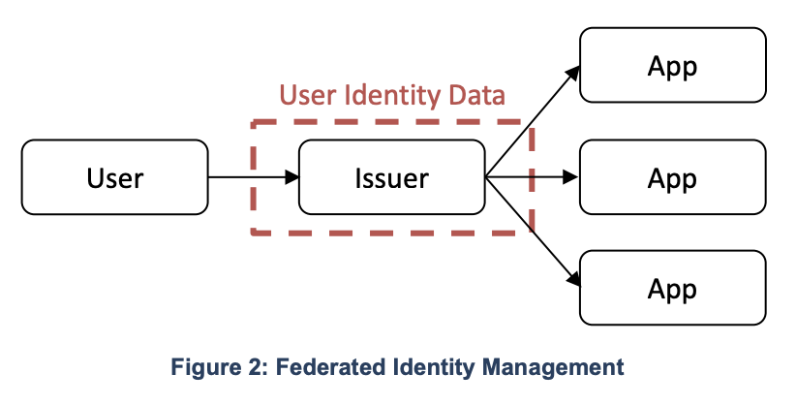
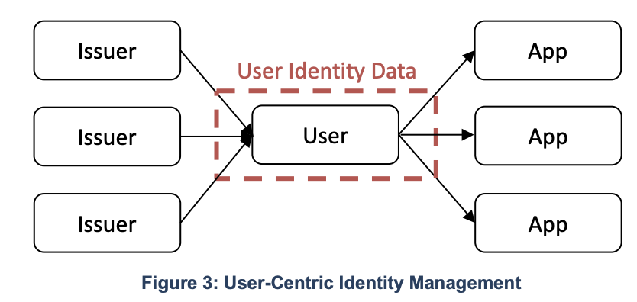
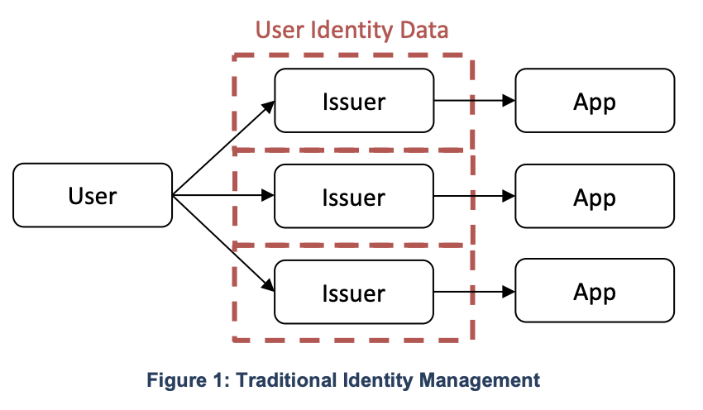

Appendix B: Blockchain Identity Management System
From NIST Cybersecurity White Paper A Taxonomic Approach to Understanding Emerging Blockchain Identity Management Systems (nist.gov)
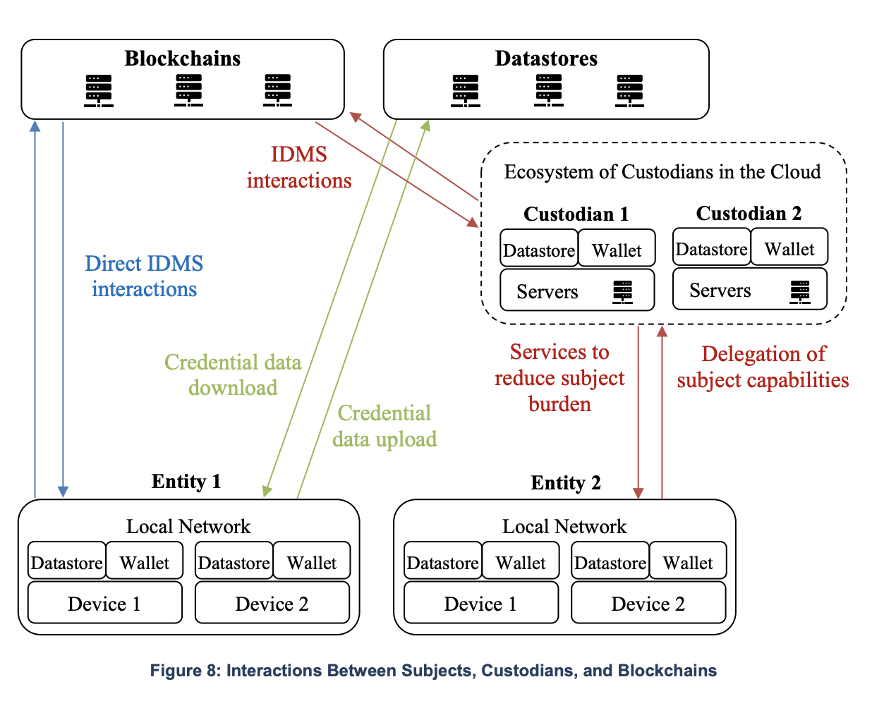

Identity Attributes, Device
Identity Attributes, Personal
Annex D: References

Per the definition of W3C, the term “entity” refers to persons, organizations, or devices (see Annex A, Glossary)
NIST Cybersecurity White Paper A Taxonomic Approach to Understanding Emerging Blockchain Identity Management Systems (nist.gov), provides a comprehensive overview of blockchain identity management systems (IDMSs). The paper identifies and describes the key components, model, building blocks, and system architectures of blockchain IDMSs, and it also discusses the potential benefits and challenges of using blockchain technology for identity management.
The concept of blockchain serving as a "trust anchor" in digital identity solutions revolves around its ability to provide a secure and decentralized foundation for verifying and managing identities. The term "trust anchor" implies that blockchain, as a reliable and tamper-resistant technology, can be a cornerstone or foundational element that instills trust in digital identity systems.
Storing and verifying digital identity on blockchains is achieved through: - Decentralized identifiers (DIDs): A type of digital identity that is stored on a blockchain and supports self-sovereign; and - Verifiable credentials (VCs): A type of digital credential that is issued by a trusted entity and can be verified on a blockchain, used to prove an individual's identity, qualifications, or other attributes.
NIST Cybersecurity White Paper A Taxonomic Approach to Understanding Emerging Blockchain Identity Management Systems (nist.gov)
In the context of "digital identity" solutions supported by blockchain technology, it is important to clarify that "decentralized identifiers (DIDs)" stored on the blockchain typically serve as unique cryptographic keys or addresses rather than containers for personal identifiable information (PII). DIDs are designed to enhance privacy and security by acting as references to off-chain data, which may include verifiable credentials or attestations. The actual PII associated with a DID is often stored off-chain in secure, user-controlled repositories (i.e., Digital Wallets). This allows users to maintain control over their data, and selectively disclose them for sharing information on a need-to-know basis without revealing unnecessary details.
Identity wallets may take various forms, such as dedicated hardware wallets, mobile applications, or even paper wallets (private keys are simply printed out and kept in a safe location). They may also come natively in a browser, an operating system, or as extensions. Wallets that are proposed “as a service” by a third-party holder that controls a user’s private keys are called custodial wallets.
For example, Hyperledger Aries is a framework released by the Hyperledger Foundation that offers several client-side components and wallet services integration to support interactions between participants in blockchain-based IDMSs.
Example: - A user can grant a third-party access to their identity data by signing a verifiable credential (VC) with their private key. The VC can then be shared with the third party, who can verify it using the user's public key. - A user can revoke access to their identity data by sending a revocation message to the third party. The revocation message can be signed with the user's private key to ensure its authenticity. - A solution can offer a consent management system allowing users to grant and revoke access to their identity data to different third parties. The consent management system can be integrated with the digital identity solution to provide a seamless user experience. A digital identity solution can use self-sovereign identity principles to give users control over their own identity data.

