United Nations
Internet Governance Forum

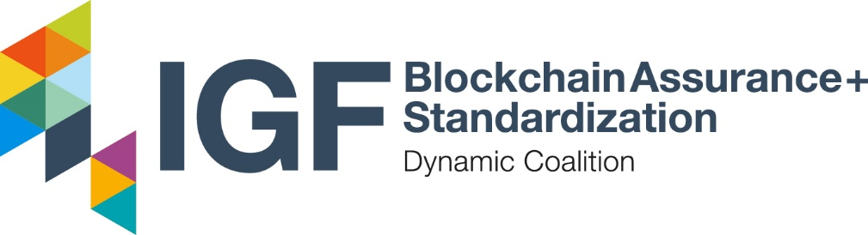

2024 Annual Report:
Trusting Blockchain Solutions

Version 0.1A
Date: Month, Day Year

1 Introduction 1
1.1 Background 1
1.2 Purpose 1
1.3 Scope 1
2 Challenge 1
3 Solution 1
3.1 Standards 1
3.2 Assessment Methodology 1
3.3 Training & Credentialing 1
3.4 Reporting Framework 1
3.5 Governance 1
4 Conclusion 1
Appendix A: Glossary 1
Appendix B: Resources 1

Executive Summary

Introduction

Background

Purpose

Scope

Challenge

Solution

Standards

Assessment Methodology

Training & Credentialing

Reporting Framework

Governance

Conclusion

Appendix A: Glossary

Term | Definition

Appendix B: Authors & Contributors

Special Thanks are extended to the following authors & contributors to this report:

