Introduction
The Government Blockchain Association (GBA) has established a certification program for Emerging Technology Acquisition Professionals. The certification program includes the full lifecycle from acquisition planning to post award activities. The certification program includes a series of courses, tests, and exercises to demonstrate proficiency in public and private acquisition environments. The certification is not specific to any organization, geography or industry. It is intended to be broadly applicable to acquisition and procumbent professionals.
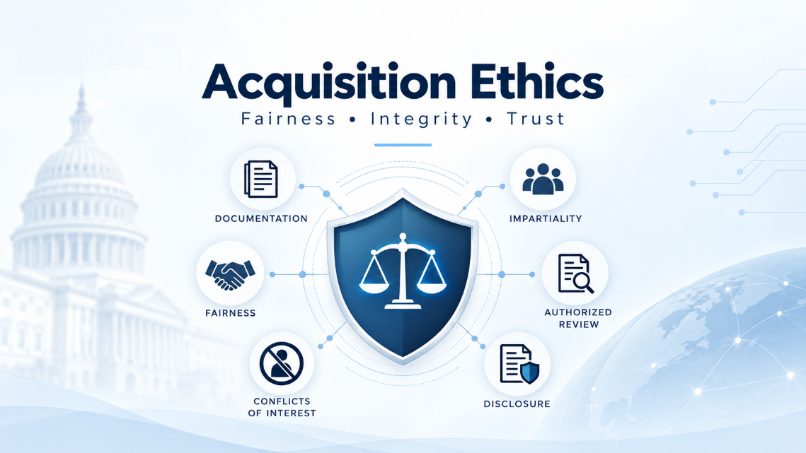

Certification Scope
The certification covers the full spectrum of skills required for acquisition professionals at all levels of seniority including:
- Specialists
- Buyers
- Managers
- Executives
The certification program also includes special domain designations for emerging technologies including:
- Artificial Intelligence
- Autonomous Systems
- Blockchain & Digital Assets
- Cybersecurity
- Quantum
- Semiconductors & Advanced Computing

About This Document
This document describes the first module of the first course in the certification program. The first course is Acquisition Foundations. One of the modules in the Foundations Course is Acquisition Ethics Module. This document describes the Module and is used as the requirements for the establishment and maintenance of the Acquisition Ethics Module.

Learning Outcomes
At the end of this module, learners should be able to:
- Identify the governing sources that apply to an acquisition ethics question, including applicable law, jurisdictional rules, organizational policy, procurement rules, contract obligations, standards of conduct, and authorized review paths
- Respond appropriately to pressure, influence, gifts, favors, preferential treatment, unsupported urgency, or attempts to bend the acquisition process
- Explain conflicts of interest and recognize where loyalties lie when personal, vendor, organizational, contractual, jurisdictional, or role-based obligations compete
- Explain ethics in an acquisition-support context
- Describe how ethics protects fairness, impartiality, trust, responsible use of resources, and confidence in the acquisition process
- Recognize why confidence in the acquisition process matters for public-sector and industry procurement decisions
- Distinguish an ethics concern from a personal preference, technical disagreement, ordinary acquisition risk, or unresolved evidence gap
- Identify when an issue may need documentation, disclosure, recusal, escalation, or authorized review

Course Structure
The topics below define the content of this module and the order in which it will be taught. Each topic connects to the learning outcomes.
ID | Topic | Coverage within the topic | Learning Outcomes
T01 | Ethics and the Acquisition-Support Role | Meaning of ethics, contribution to acquisition decisions, role boundaries, public-sector and industry applicability | 4, 5
T02 | Standards | Expected conduct, professional standards, standards of conduct, their purpose in acquisition work | 1, 4
T03 | Governing Sources | Applicable law, jurisdictional rules, organizational policy, procurement rules, contract obligations, standards of conduct, authorized review paths | 1
T04 | Consistency | Applying relevant criteria consistently, recognizing unexplained changes, documenting reasons for different treatment | 5
T05 | Fairness | Fair treatment of participants, relevant acquisition requirements, preferential treatment and review concerns | 5
T06 | Impartiality | Objective review, interests or relationships affecting judgment, appearances requiring clarification | 3, 5
T07 | Responsible Use of Resources | Organizational resources, mission or business need, expected value, responsibility within the learner’s role | 5
T08 | Trust in the Acquisition Process | Dependable conduct, honest information, evidence, reliable documentation and review | 5, 6
T09 | Confidence in the Acquisition Process | Credible decisions, understandable reasoning, stakeholder confidence in public-sector and industry procurement | 6
T10 | Ethics Concern | Recognition of possible concerns, supporting facts, affected responsibilities, limits on conclusions | 4, 7
T11 | Personal Preference | Favored vendors, products, approaches, or technologies, reasons for a preference, relevant evidence | 7
T12 | Technical Disagreement | Differences in professional judgment, supporting evidence, appropriate technical review | 7
T13 | Ordinary Acquisition Risk | Acquisition uncertainty, documentation, monitoring, risk and program review | 7
T14 | Unresolved Evidence Gaps | Missing information, unverified claims, assumptions, evidence requests, further review | 7
T15 | Pressure and Influence | Unsupported urgency, vendor and sponsor pressure, favors, preferential treatment, attempts to bypass the process | 2
T16 | Conflicts of Interest | Personal, financial, and organizational interests, vendor and personal relationships, related concerns involving gifts, bribes, kickbacks, graft, or undisclosed influence | 2, 3, 8
T17 | Loyalty | Obligations to the role, organization, applicable rules, and integrity of the record, competing loyalties | 3
T18 | Documentation | Issue summaries, known facts, assumptions, relevant sources, evidence, unresolved questions | 8
T19 | Disclosure | Information requiring disclosure, appropriate recipients, applicable requirements, review needs | 3, 8
T20 | Recusal | Nonparticipation in a matter, applicable requirements, scope of restrictions, clarification and authorized review | 8
T21 | Escalation and Authorized Review | Reporting and review paths, concerns beyond the learner’s authority, referral and follow-up | 1, 2, 8

